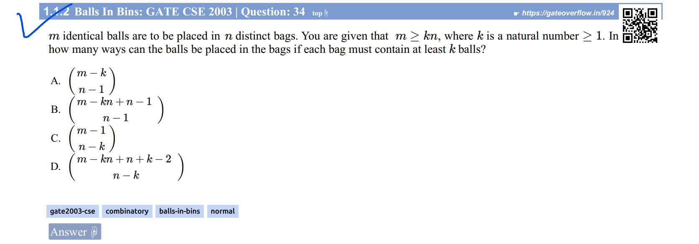

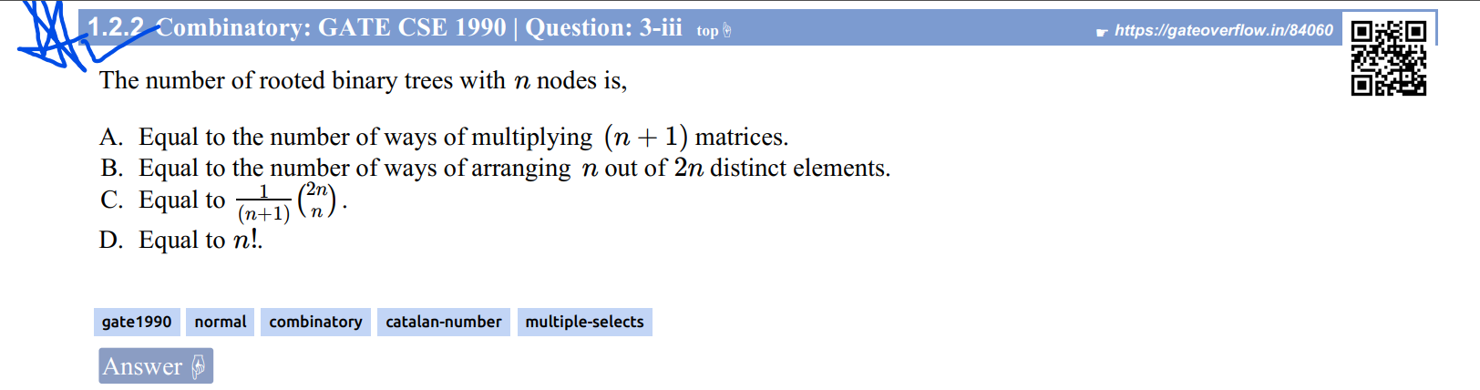

Ans:

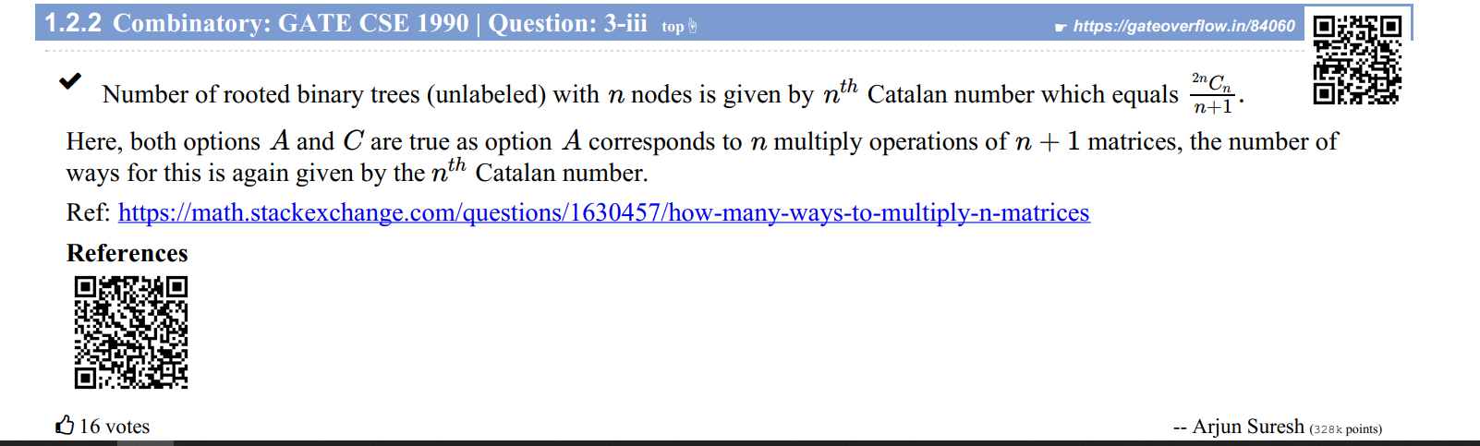



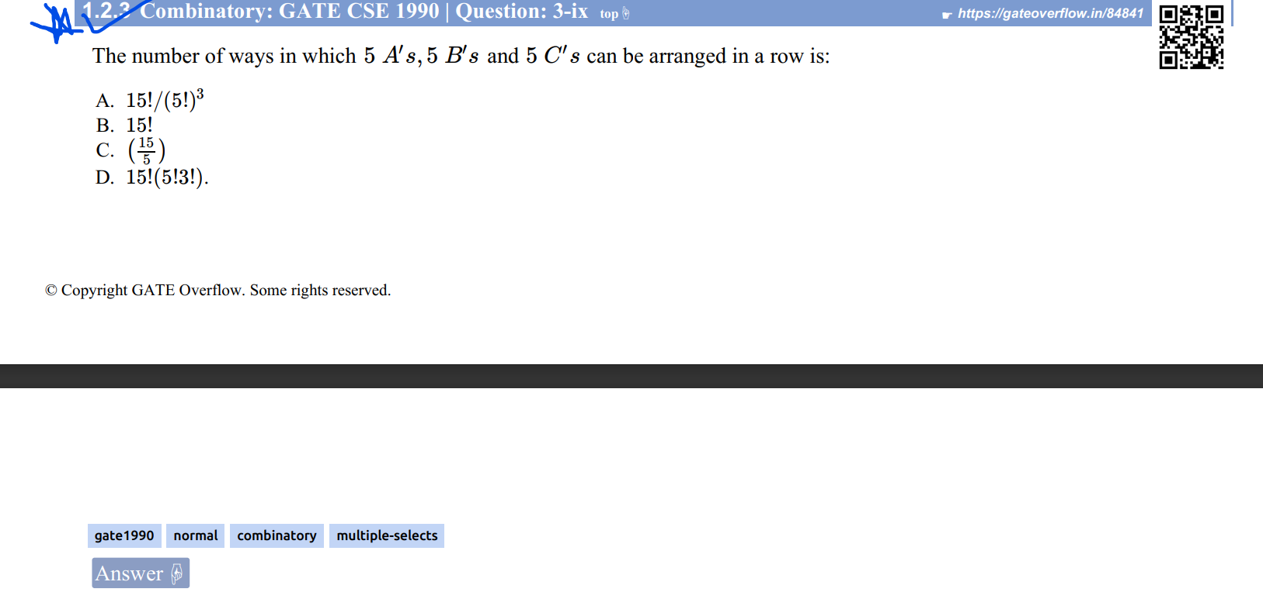

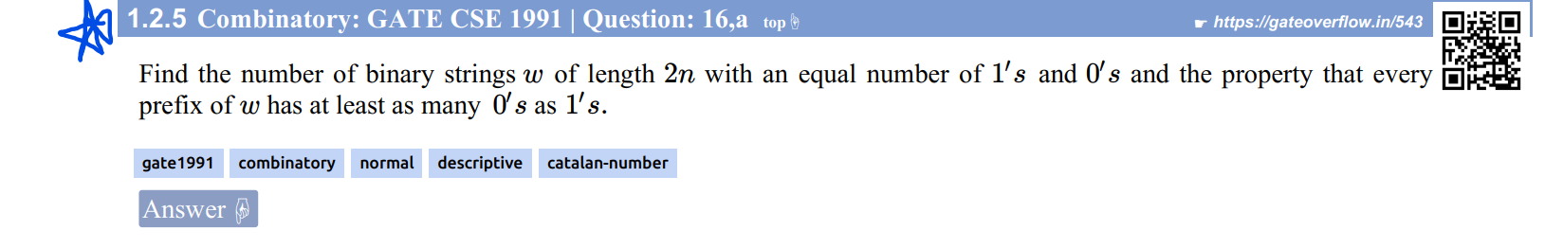

Ans:

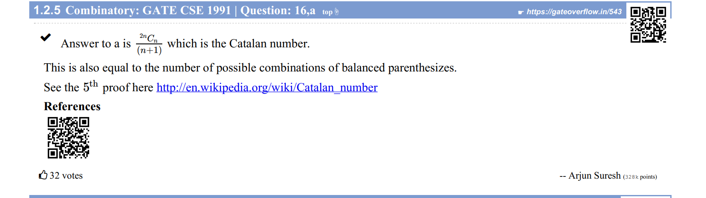

<http://en.wikipedia.org/wiki/Catalan_number>

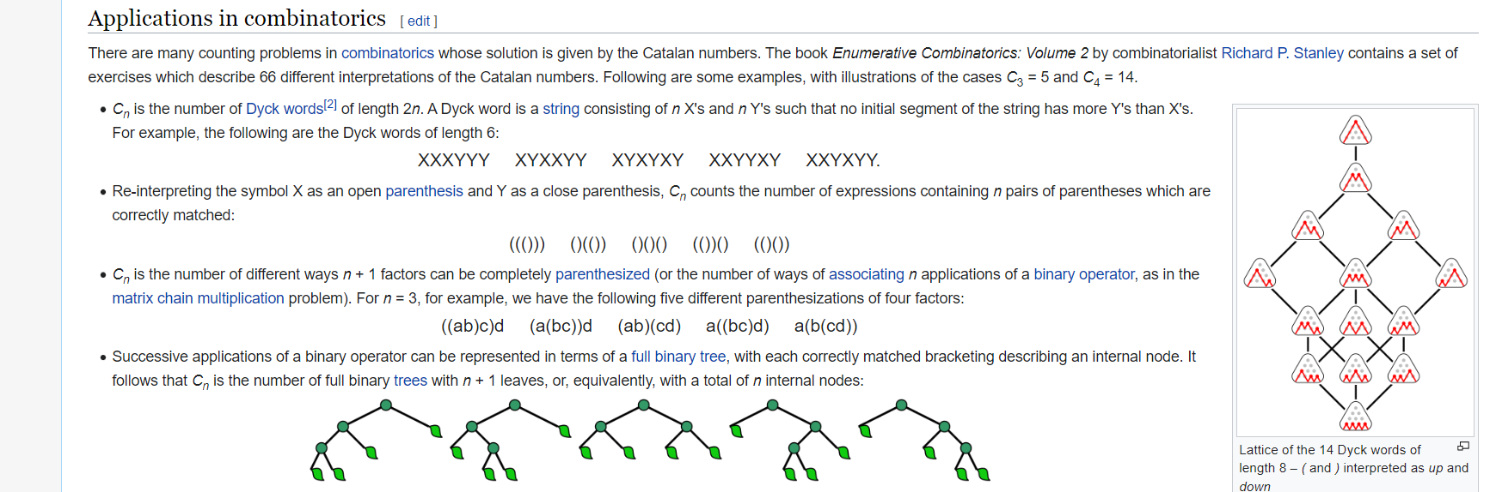

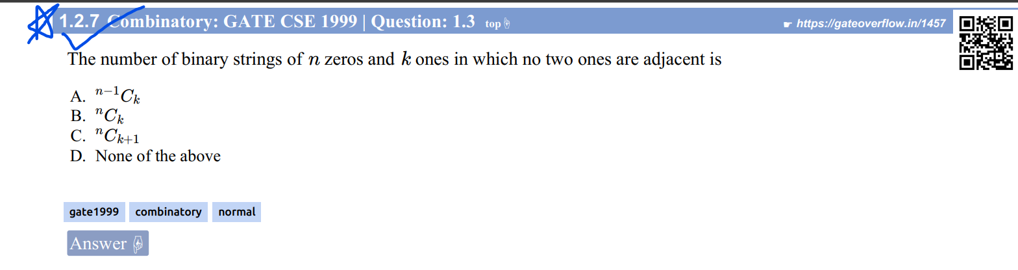

Ans: 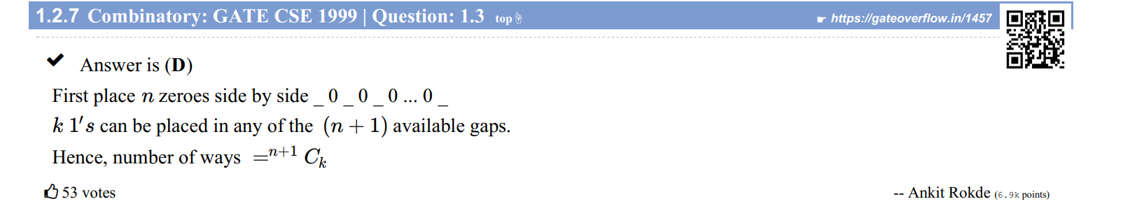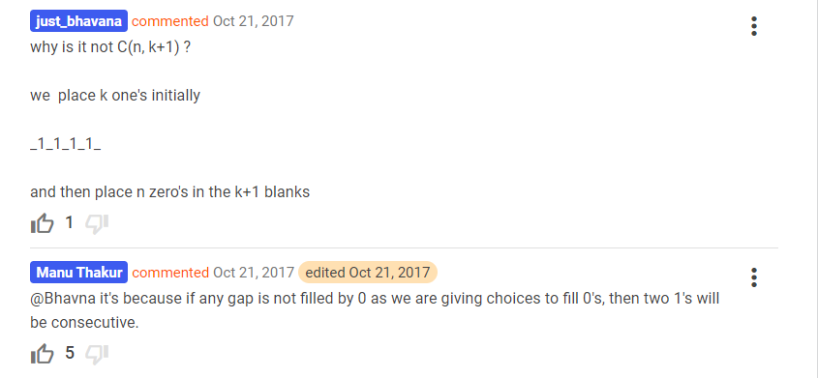

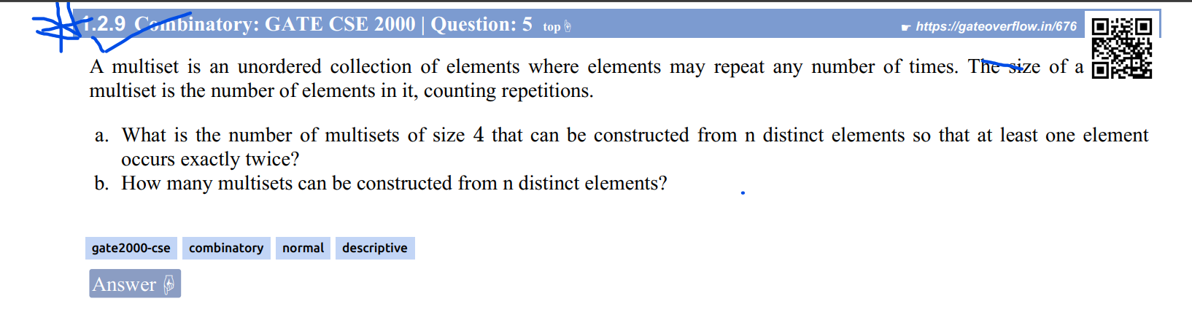

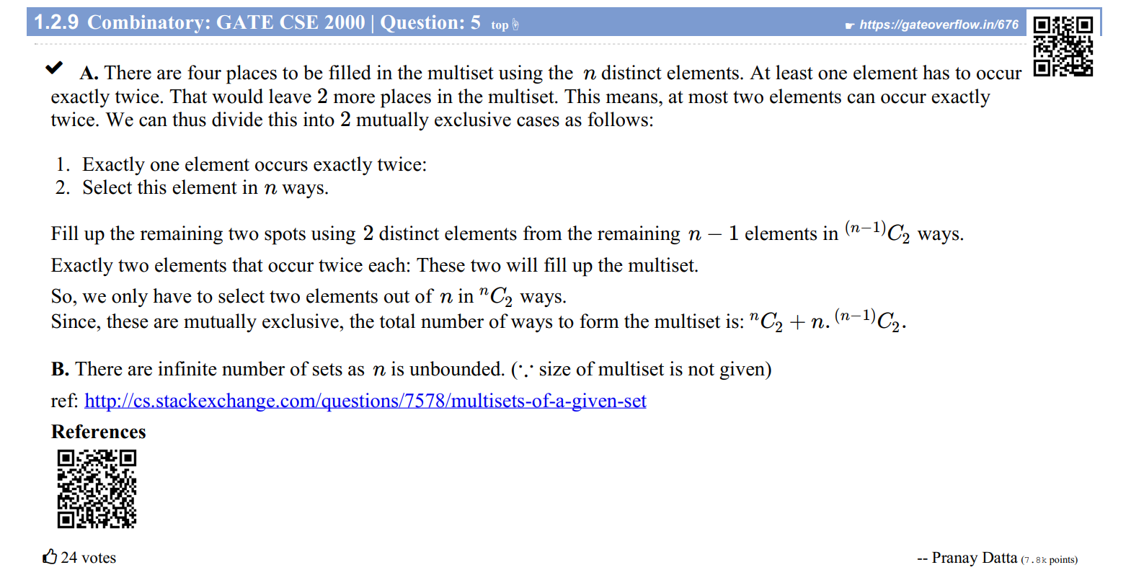

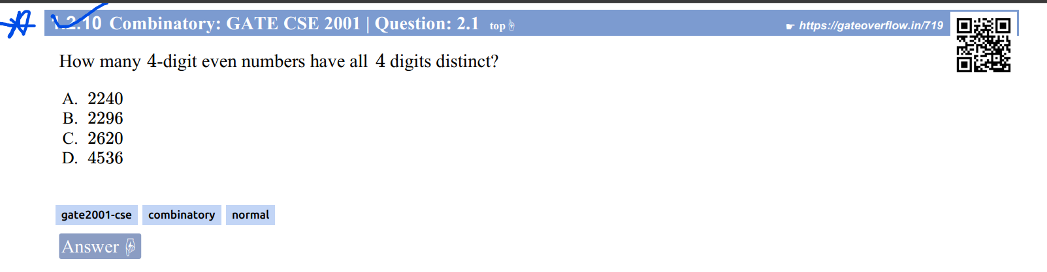

Ans:

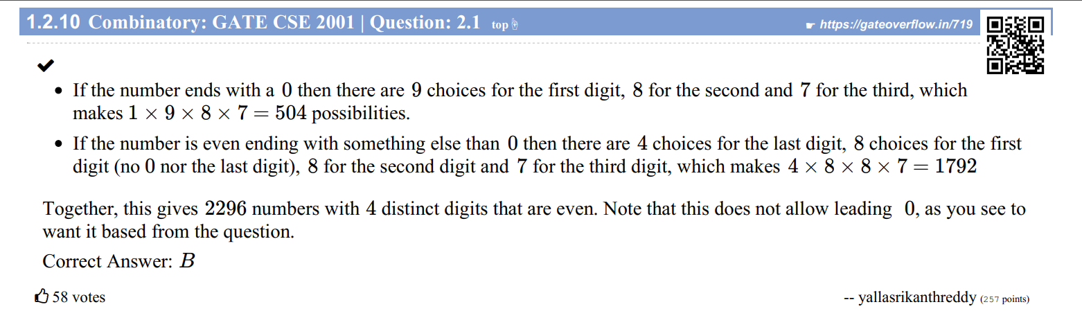

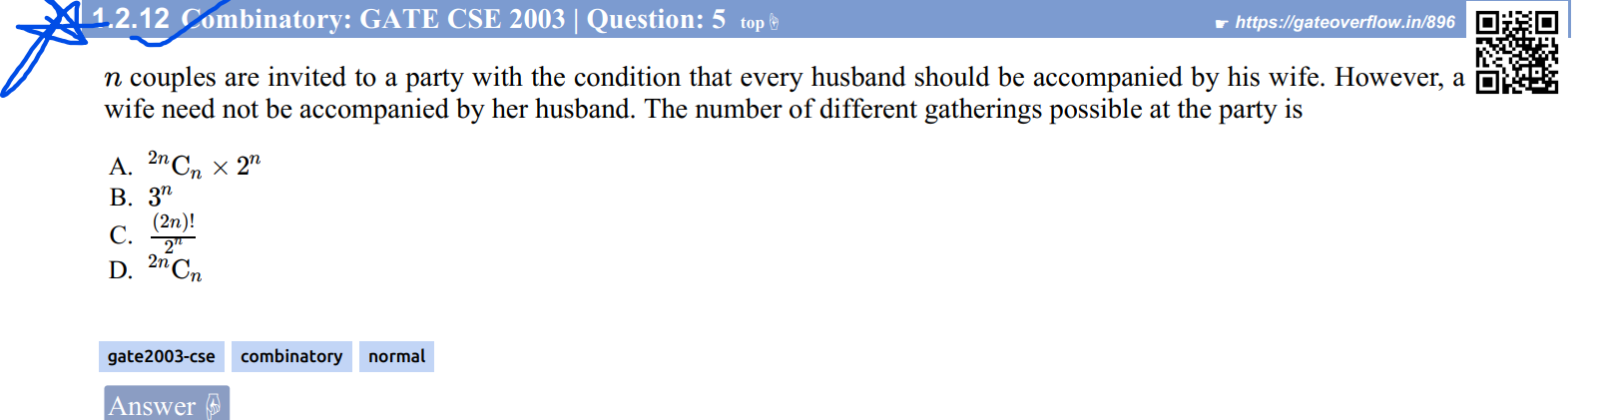

Ans:

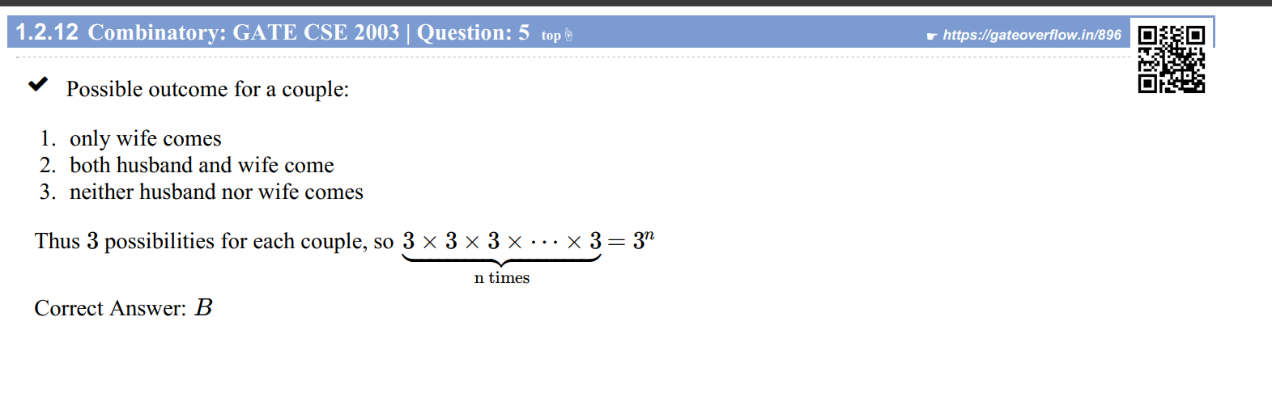

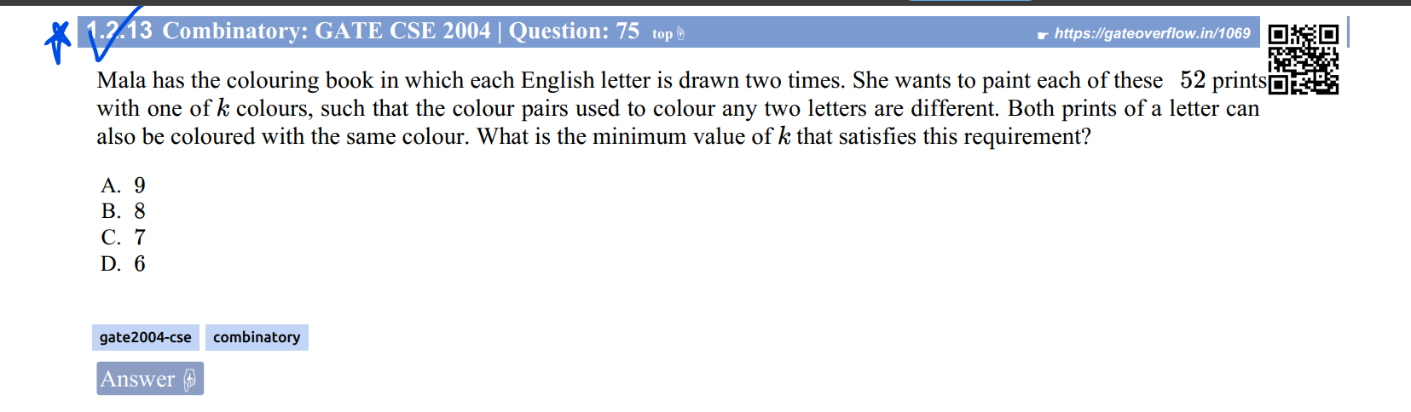

Ans: <https://www.youtube.com/watch?v=fEkc4sZxTWc>

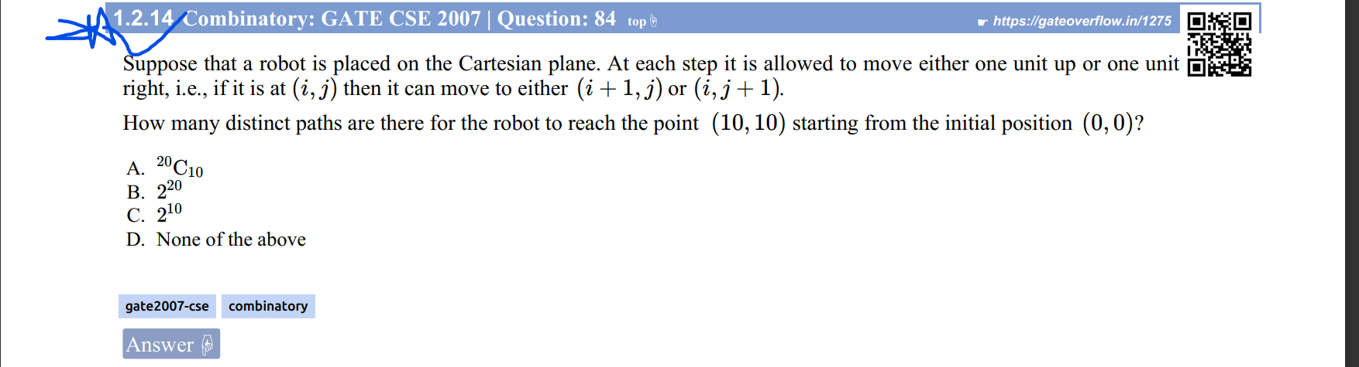

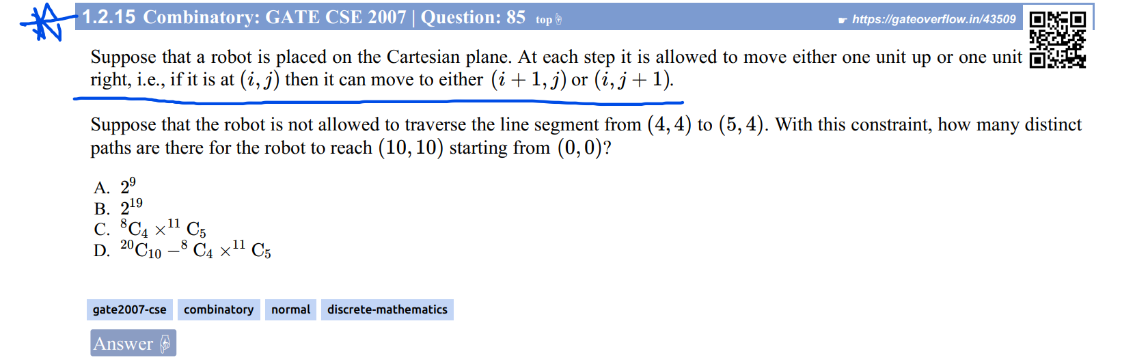

Ans: <https://www.youtube.com/watch?v=riyqOPgRC64>

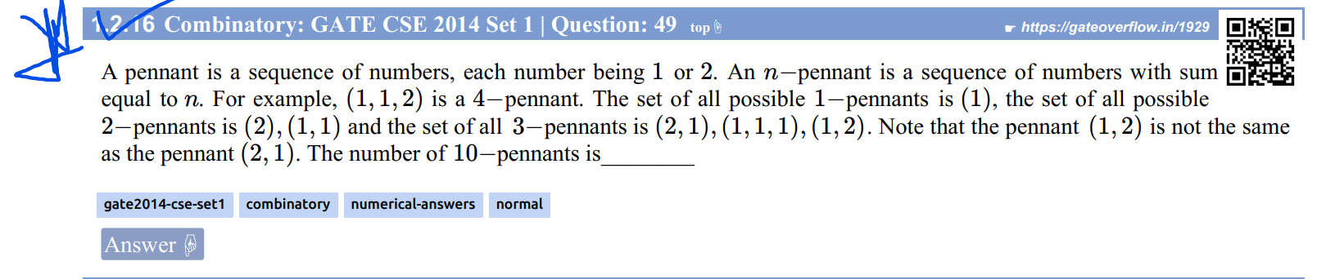

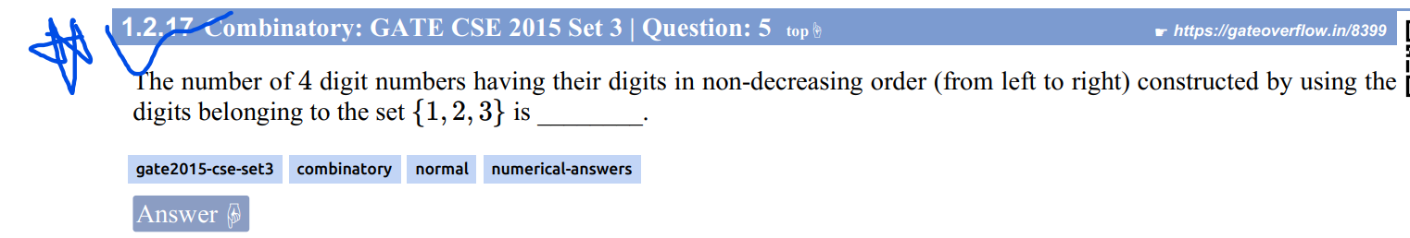

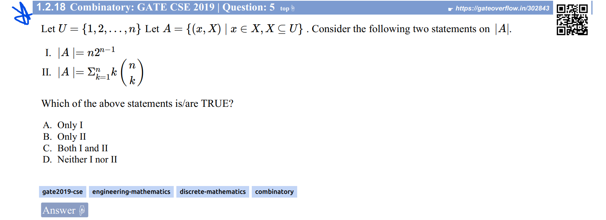

Ans: 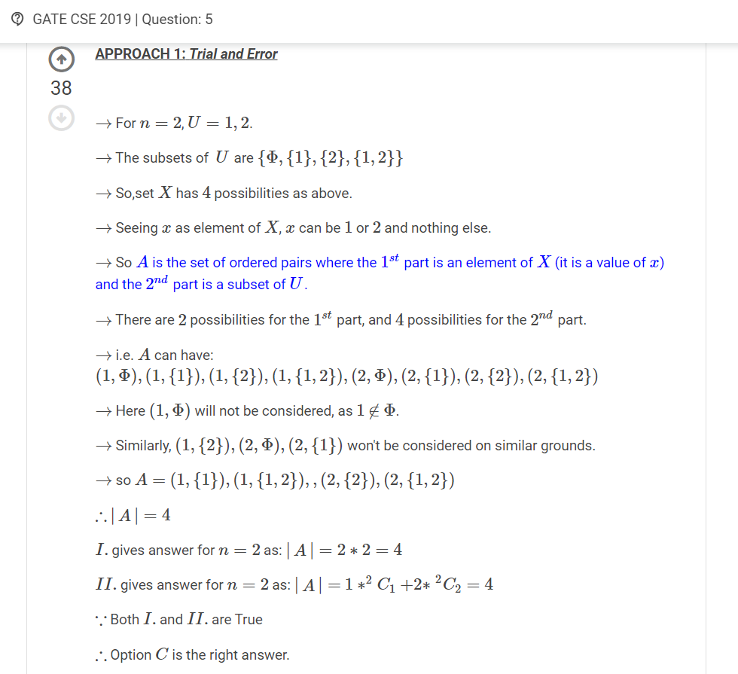

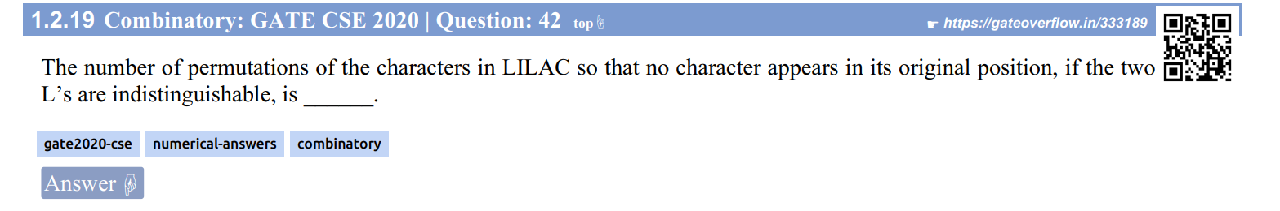

Ans:

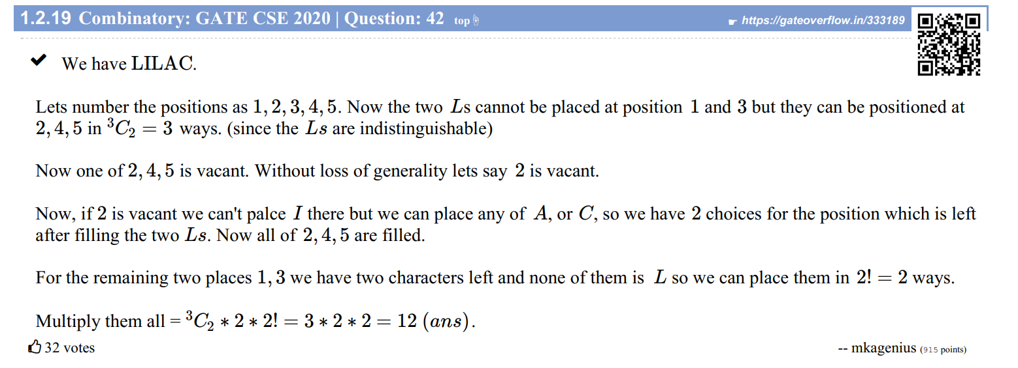

[Arrangements and Derangements with Repetition - YouTube](https://www.youtube.com/watch?v=ZT8zBvCr7L8)

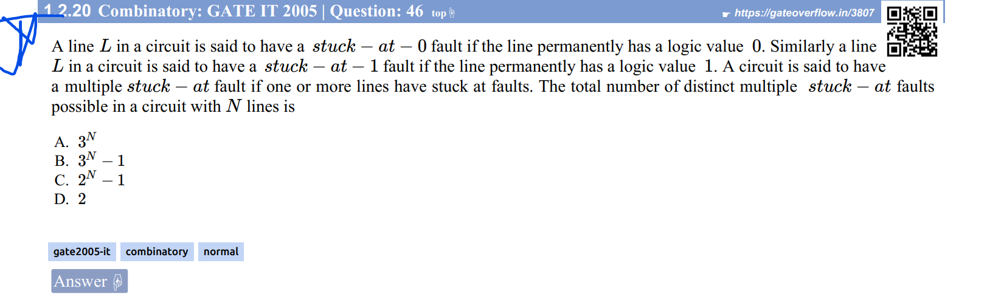

Ans: <https://www.youtube.com/watch?v=-ShM2CJwnbQ>

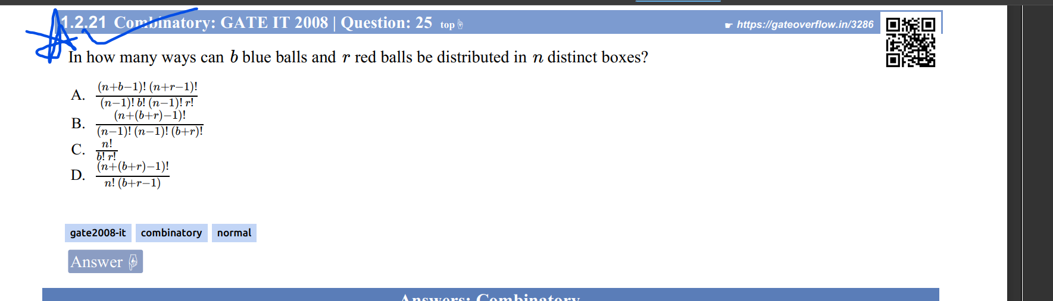

[combinatorics - In how many ways can b blue balls and r red balls be distributed in n distinct boxes.? - Mathematics Stack Exchange](https://math.stackexchange.com/questions/2339270/in-how-many-ways-can-b-blue-balls-and-r-red-balls-be-distributed-in-n-distinct-b/2339276#2339276?newreg=6bbae43ddefb45f0b61c6f96d81a3e82)

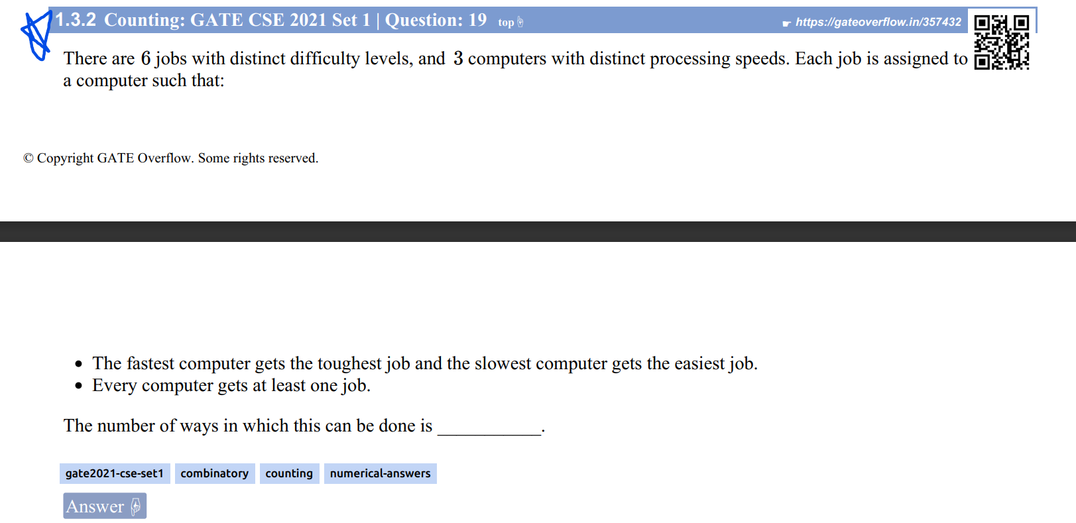

Ans:

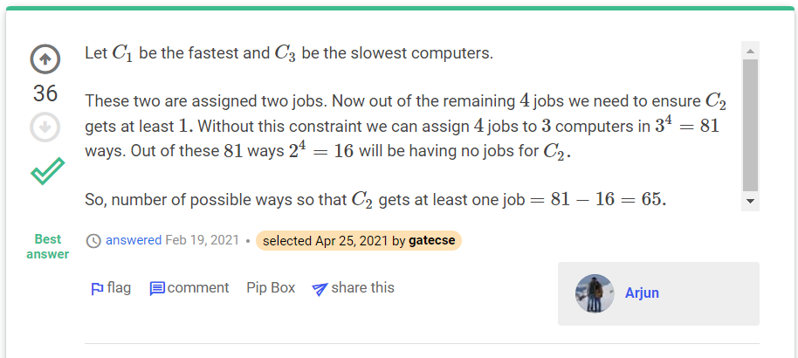

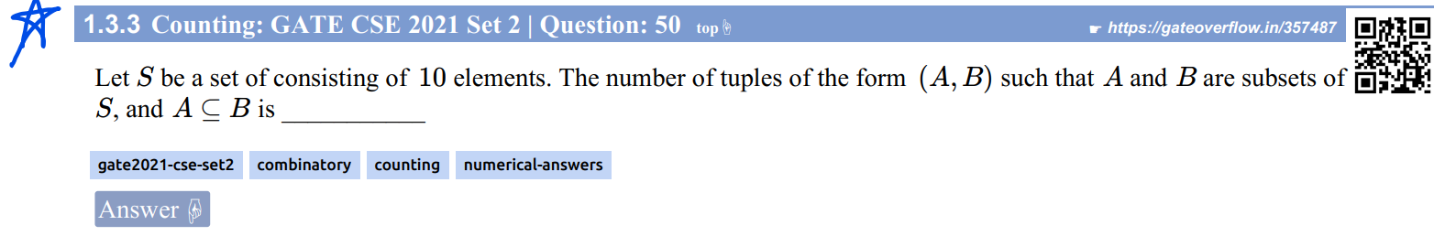

<https://gateoverflow.in/357487>

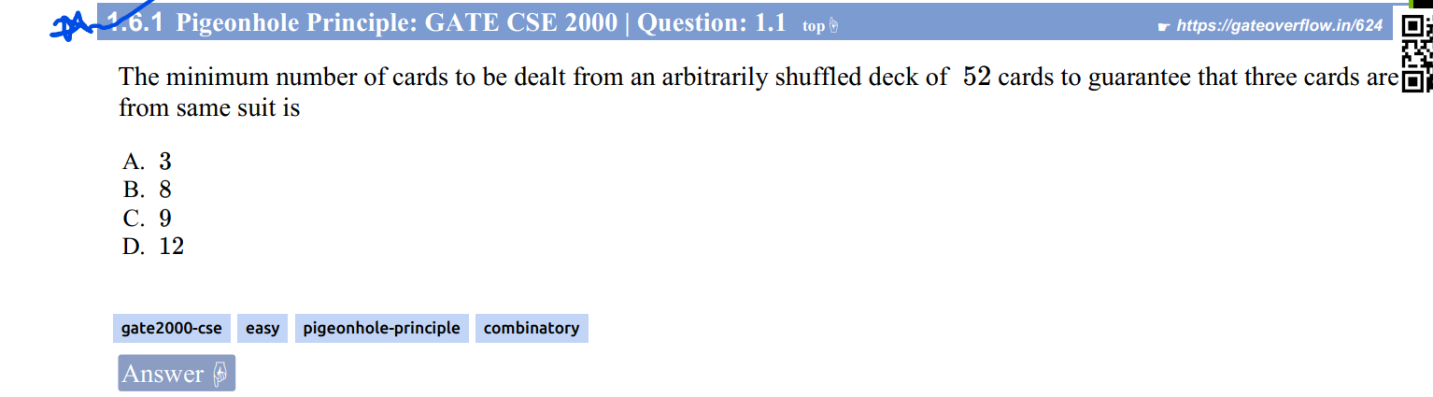

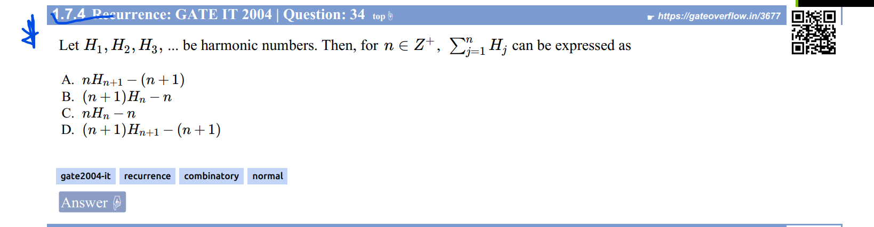

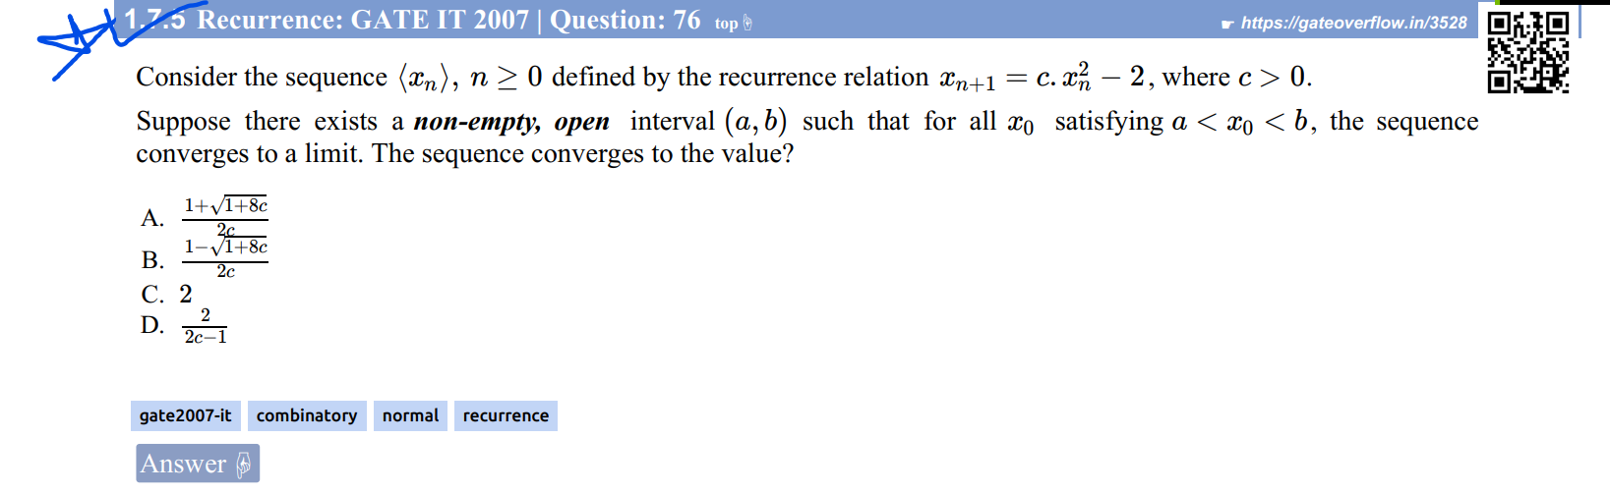

Read Ankit Gupta’s answer

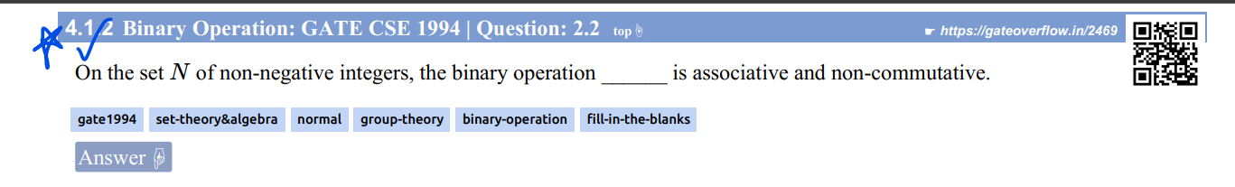

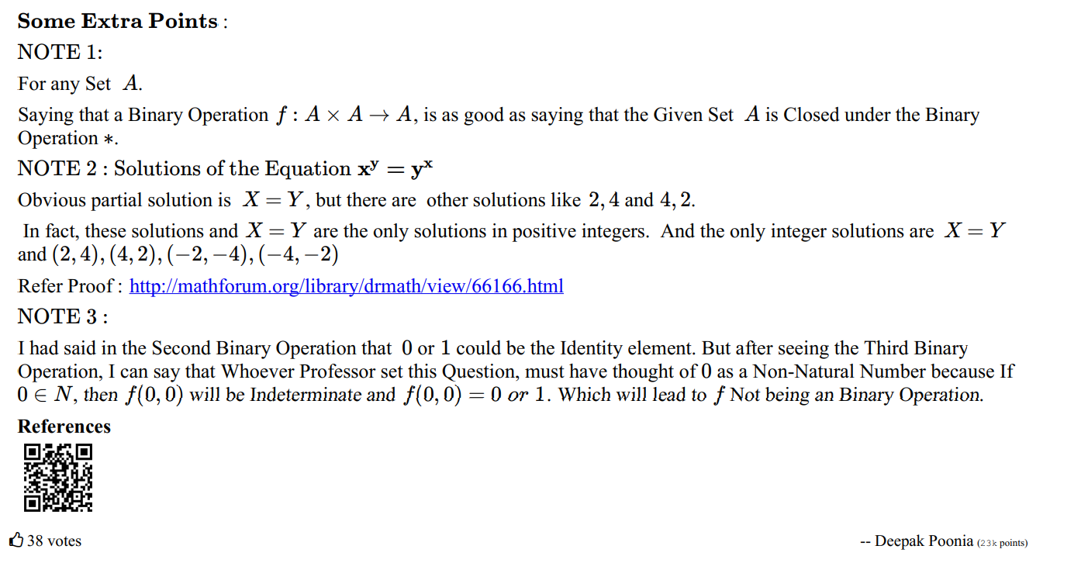

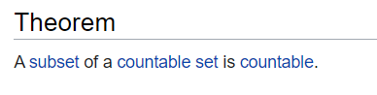

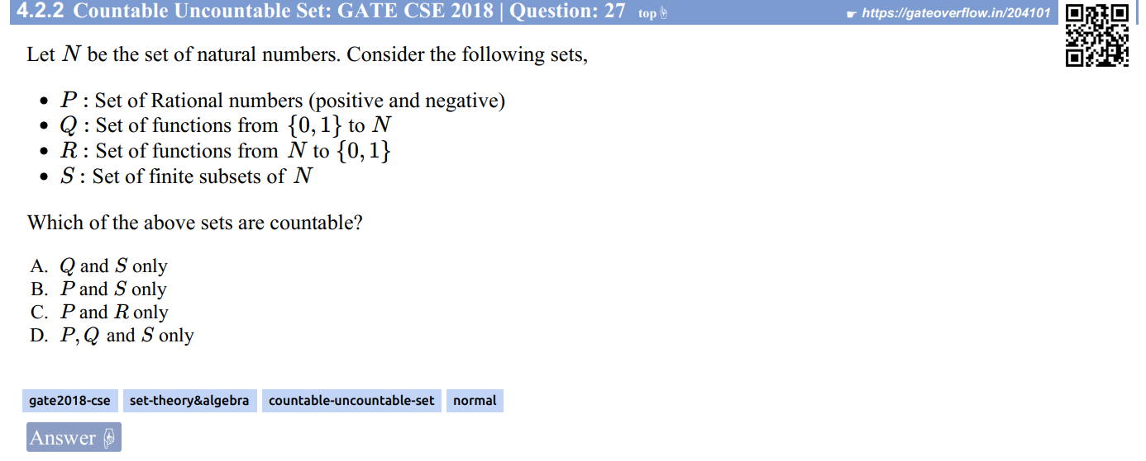

Ans:

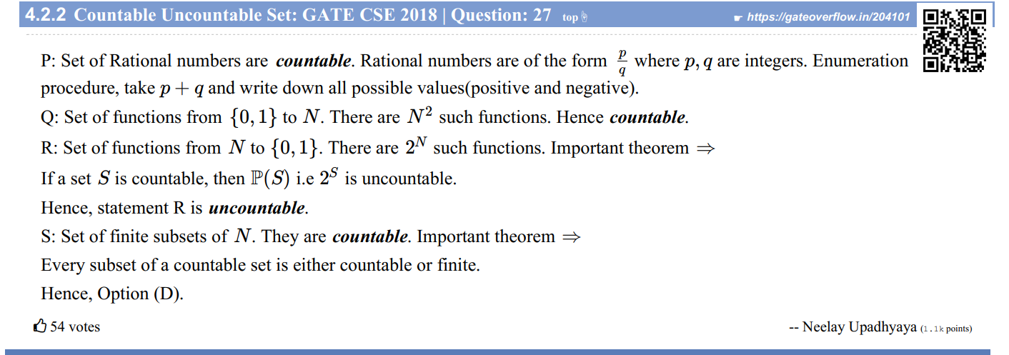

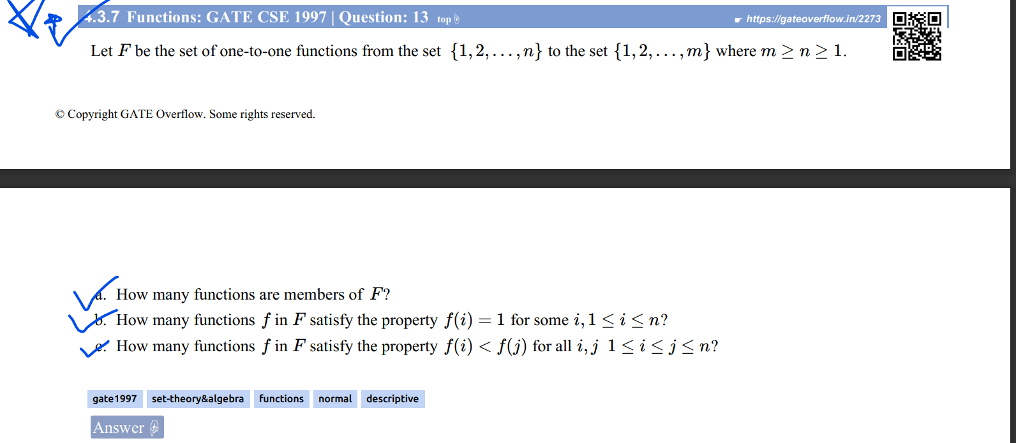

Ans:

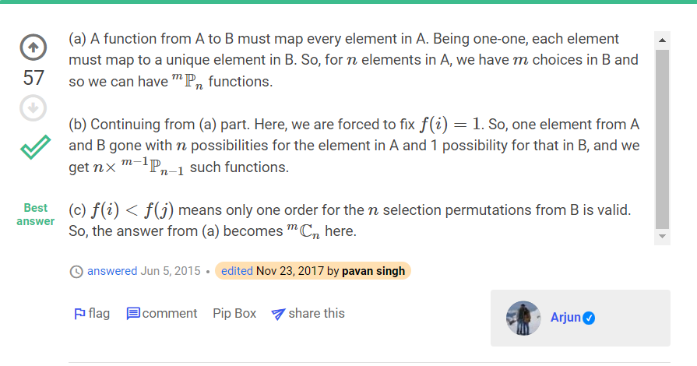

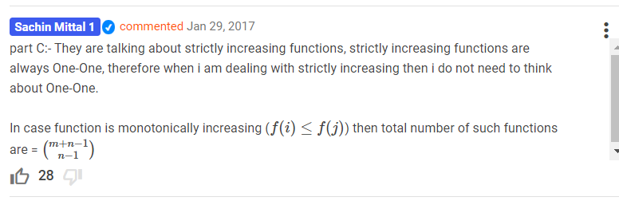

Didn’t understand the next question:-

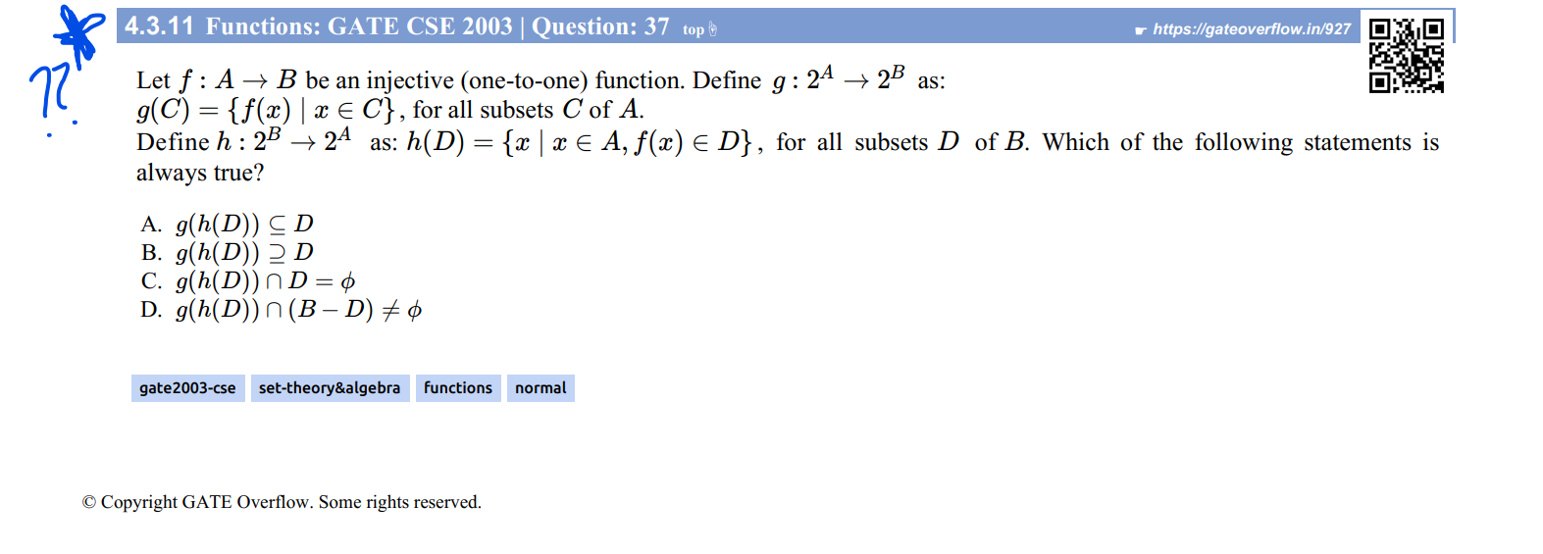

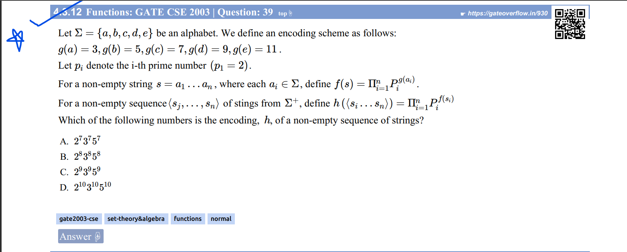

Ans: 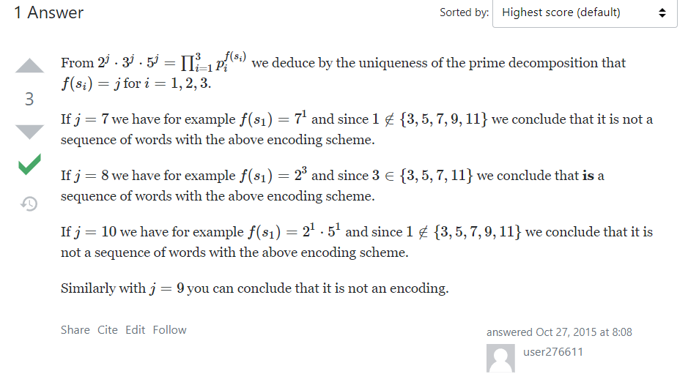

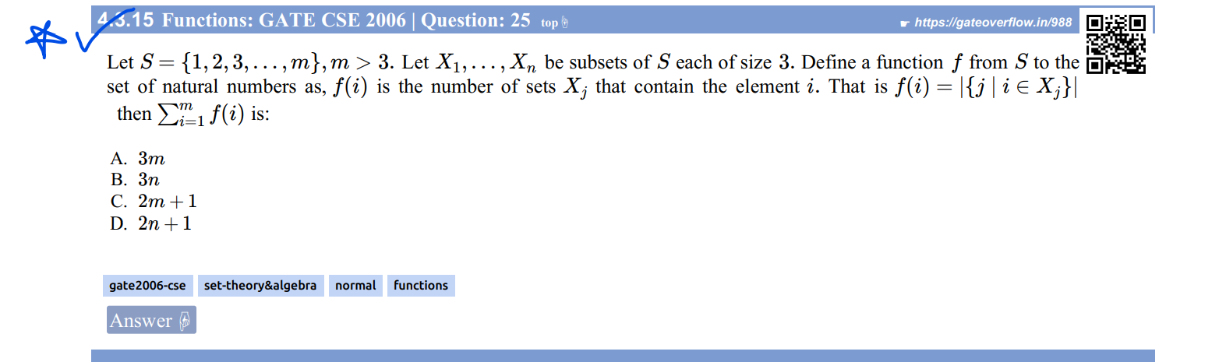

Easy only. Just check more.

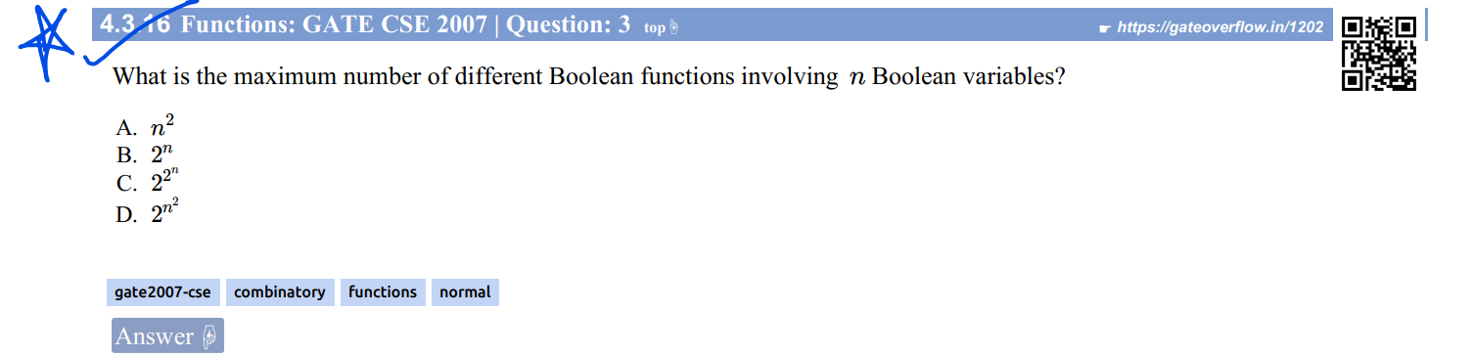

Ans:

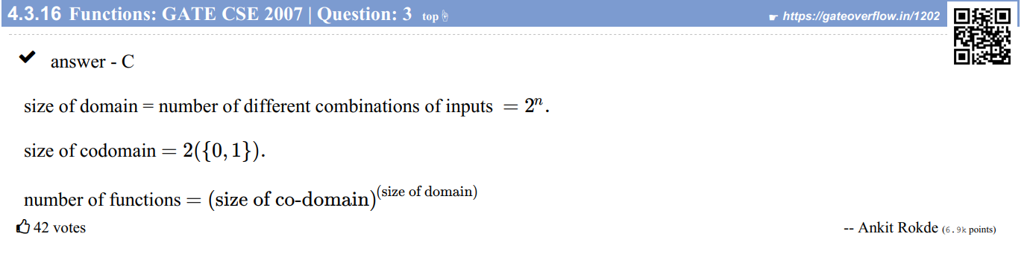

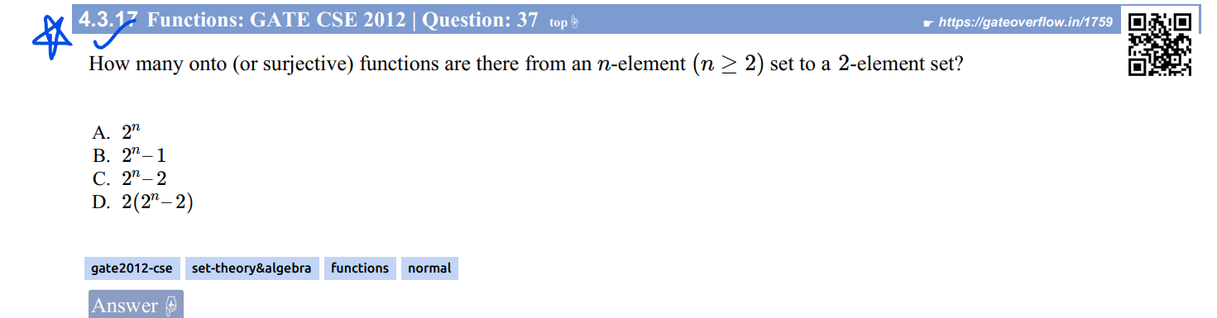

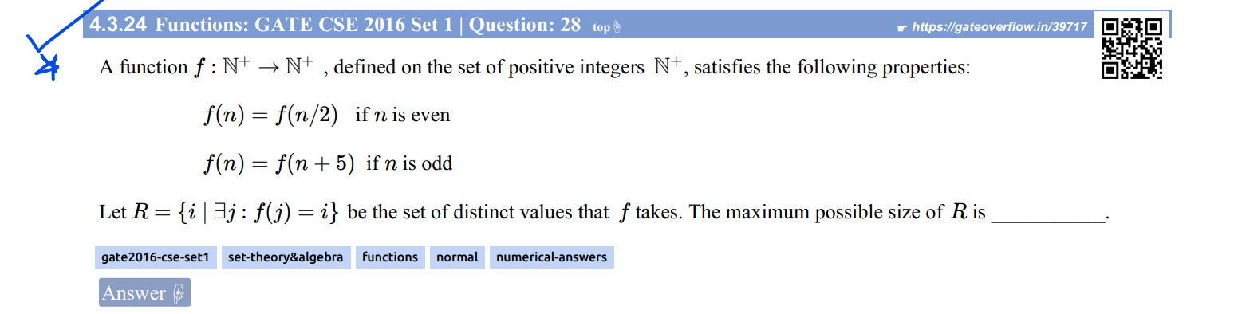

Ans:

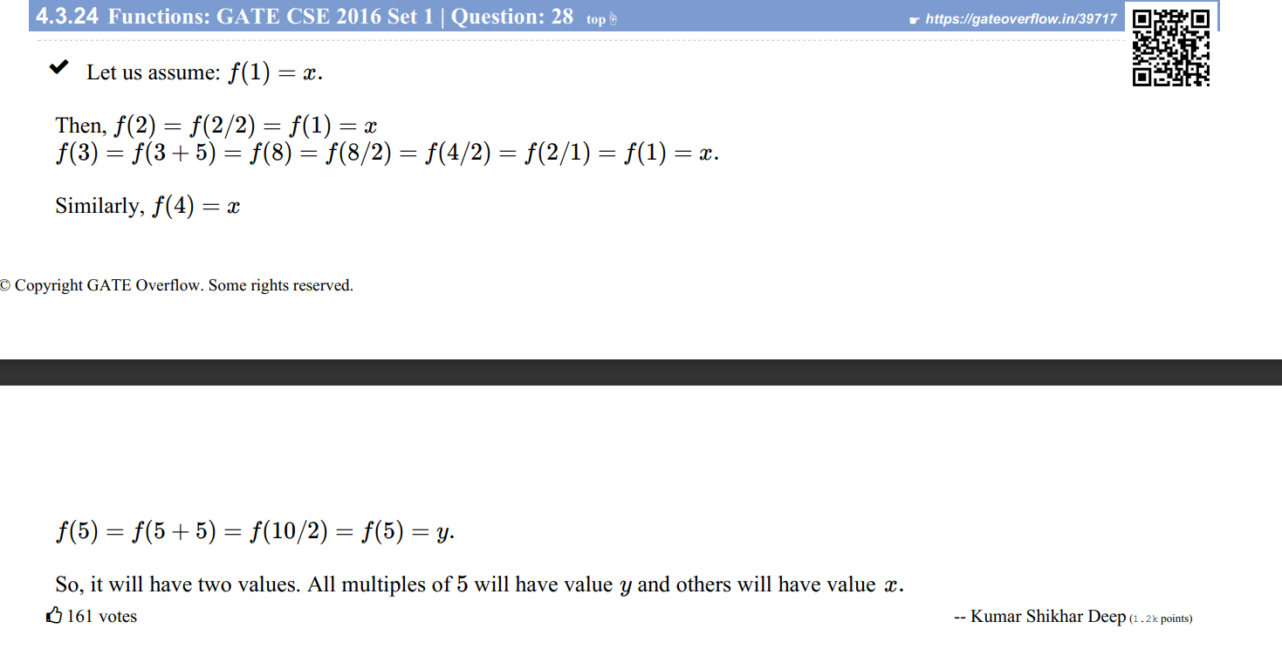

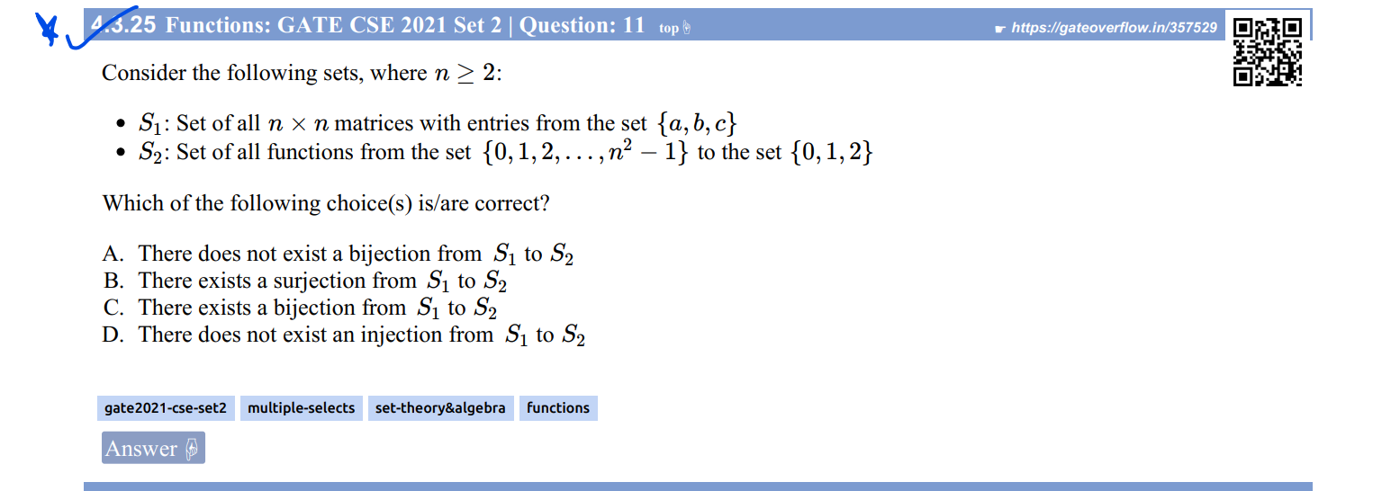

Ans: 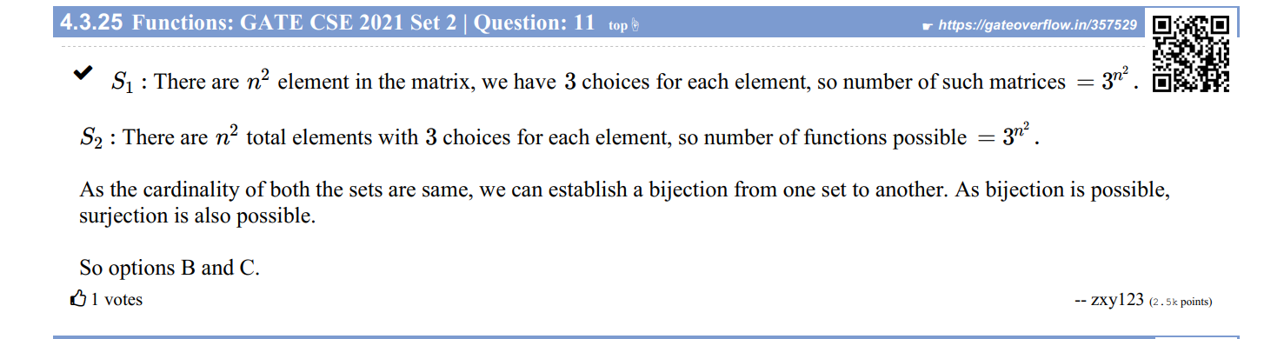

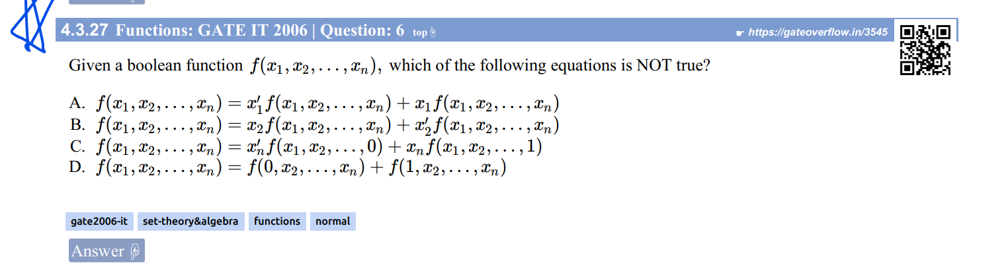

Ans:

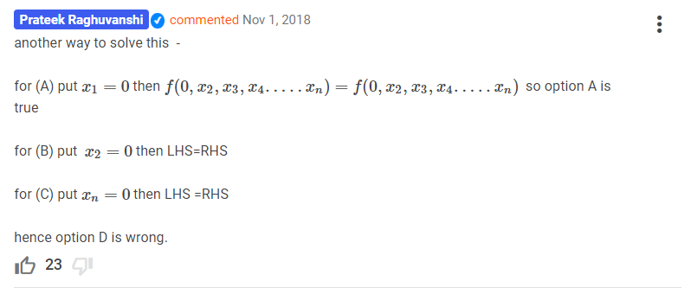

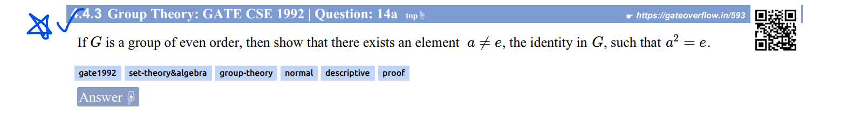

Ans: Read the GO Soln @ [GATE CSE 1992 | Question: 14a - GATE Overflow for GATE CSE](https://gateoverflow.in/593/gate-cse-1992-question-14a#88926)

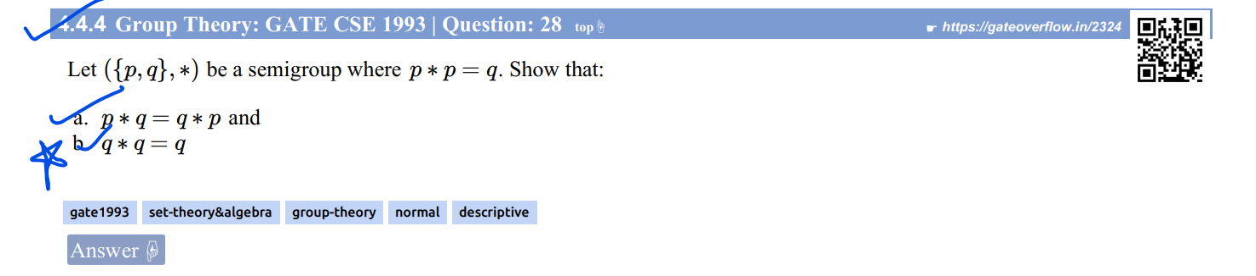

See GO soln for part b. @ [GATE CSE 1993 | Question: 28 - GATE Overflow for GATE CSE](https://gateoverflow.in/2324/gate-cse-1993-question-28#141574)

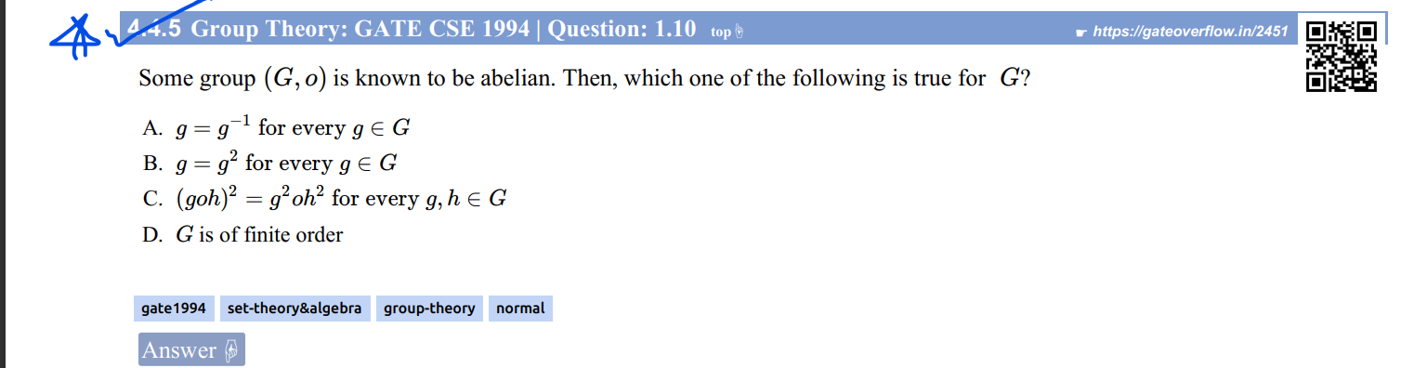

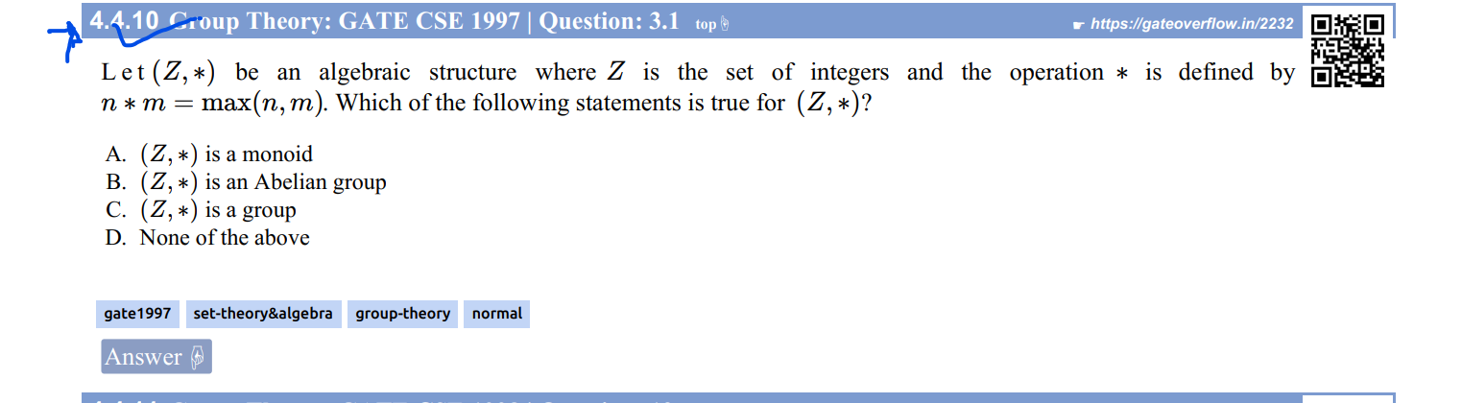

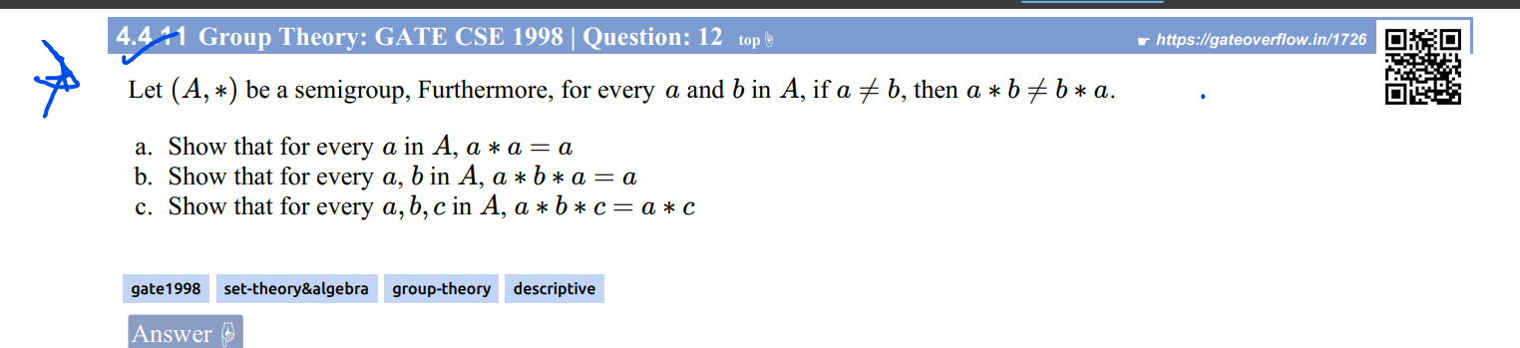



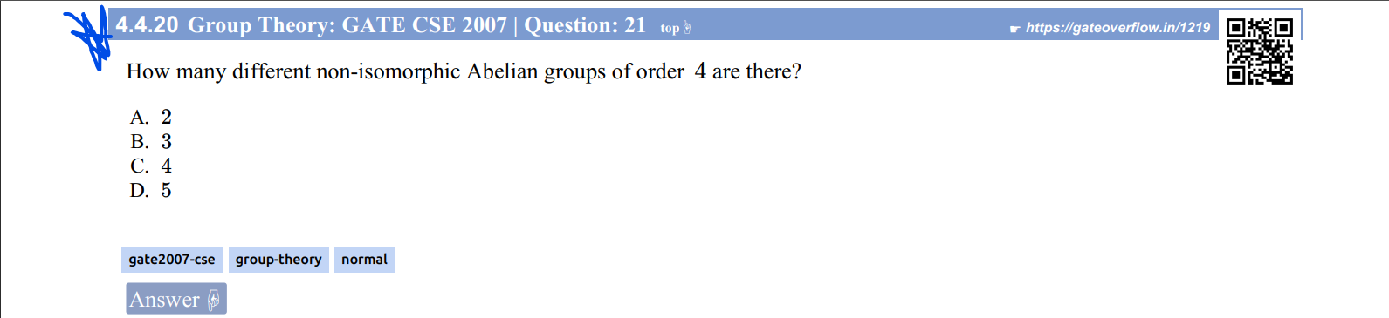

Ans:

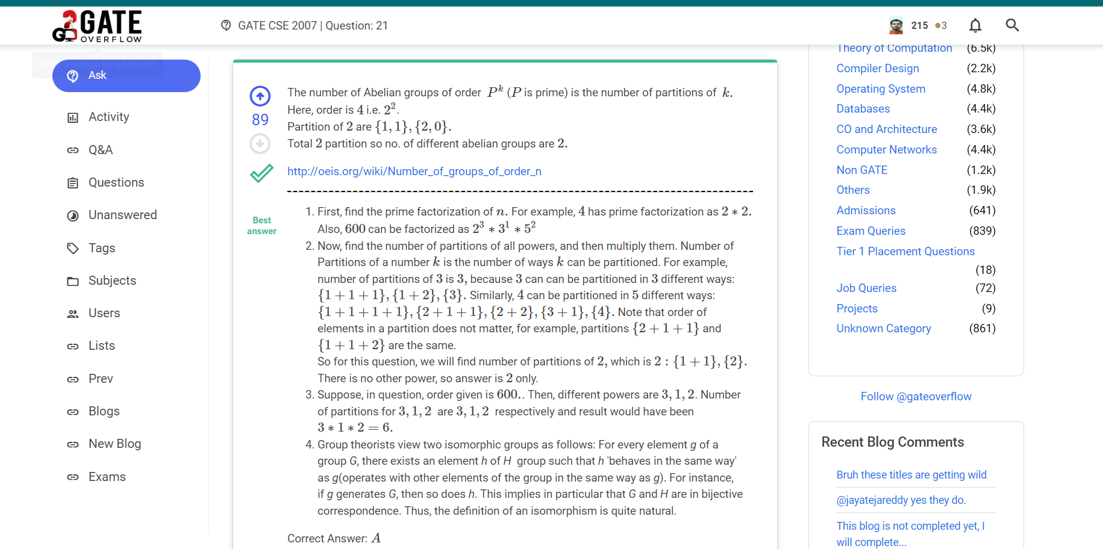

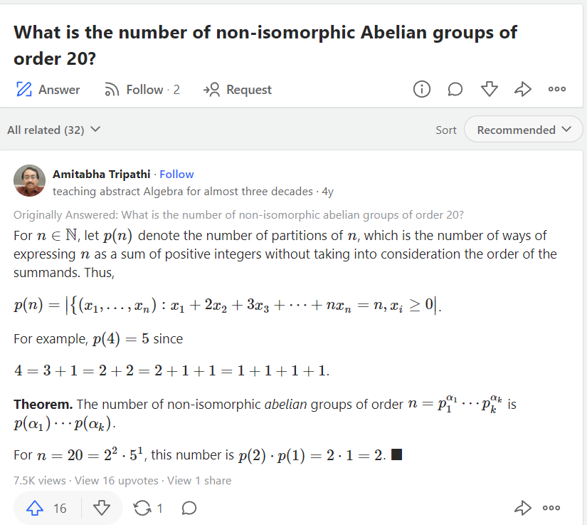

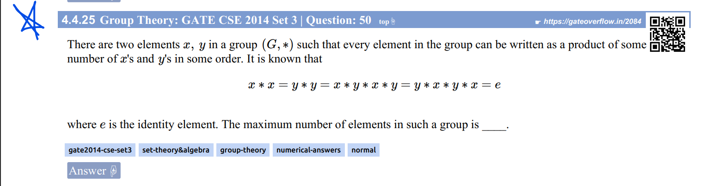

Ans:

[223. gate 2014 questions on group theory - YouTube](https://www.youtube.com/watch?v=C3Mu7qyZhng)

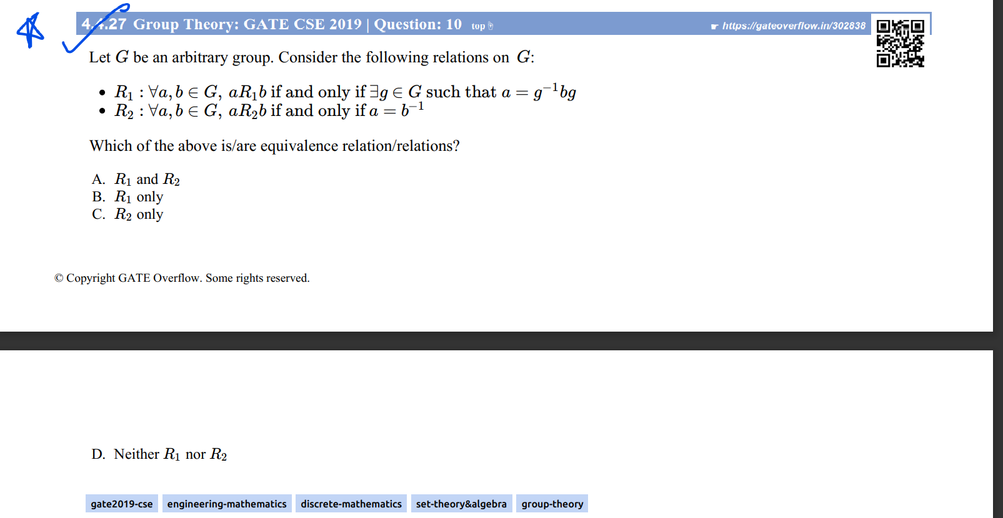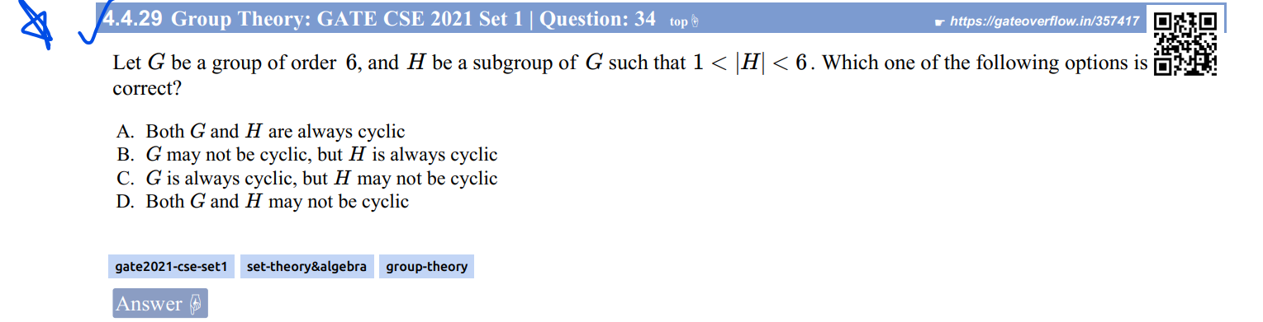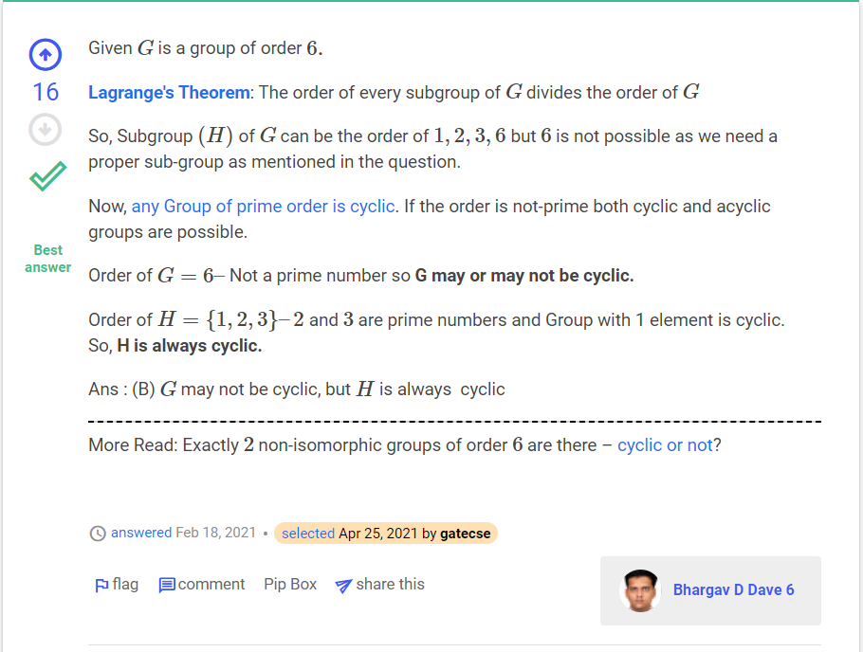

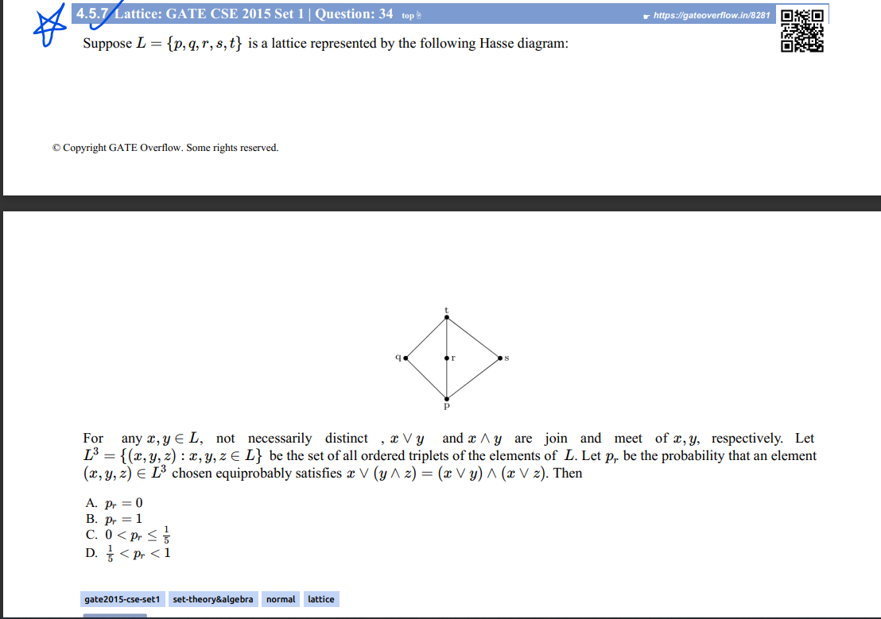

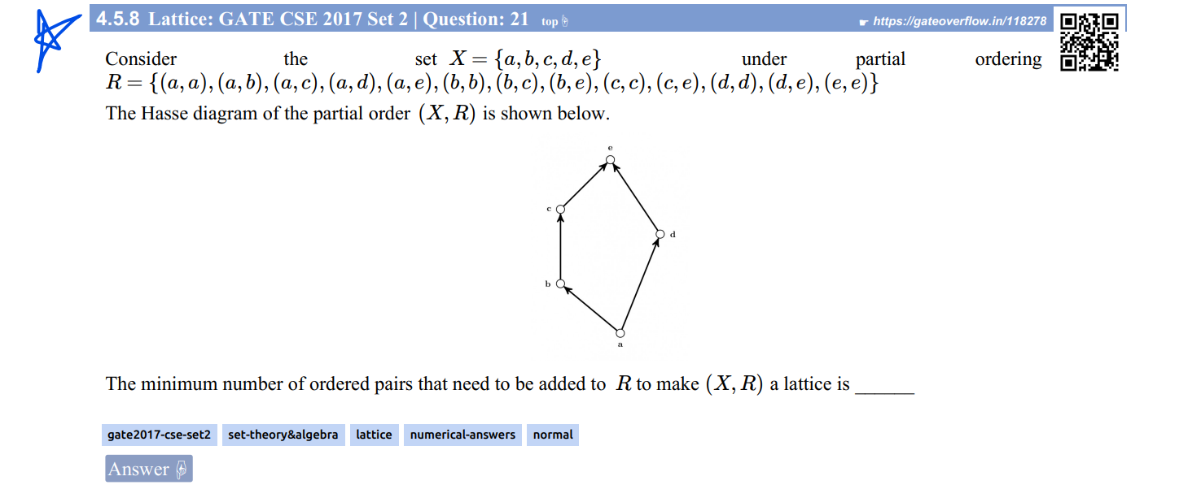

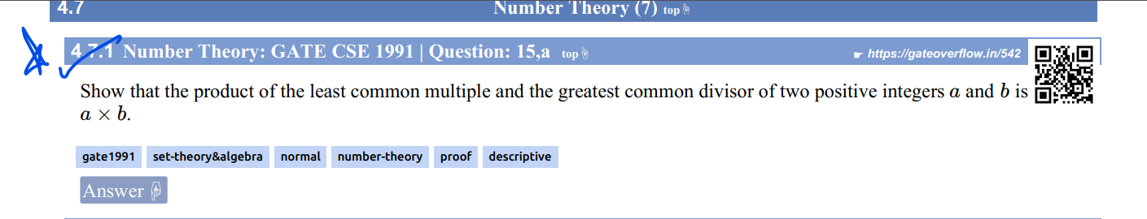

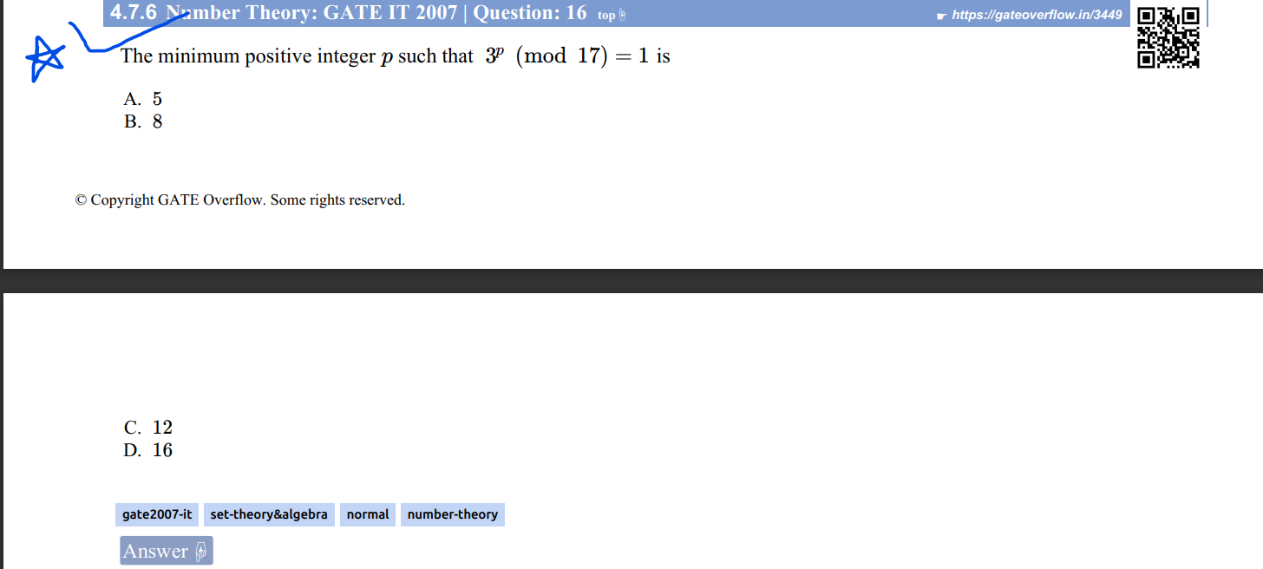

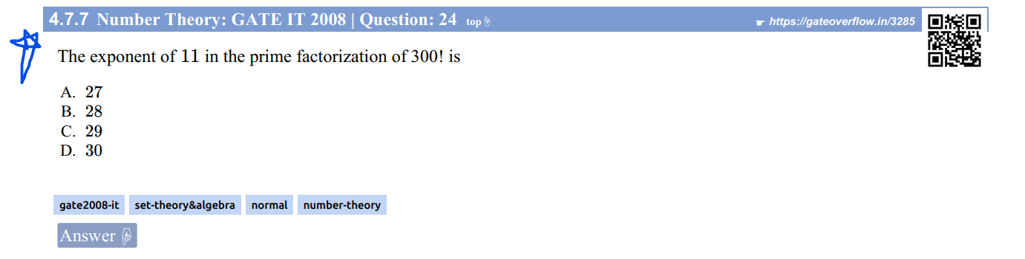

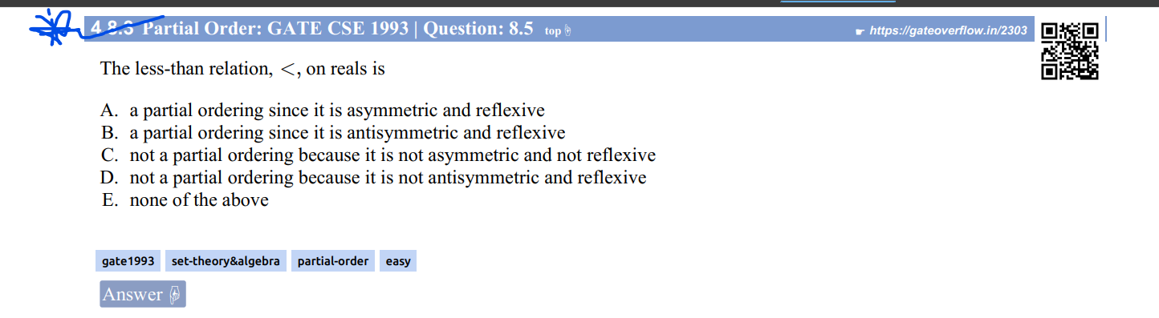

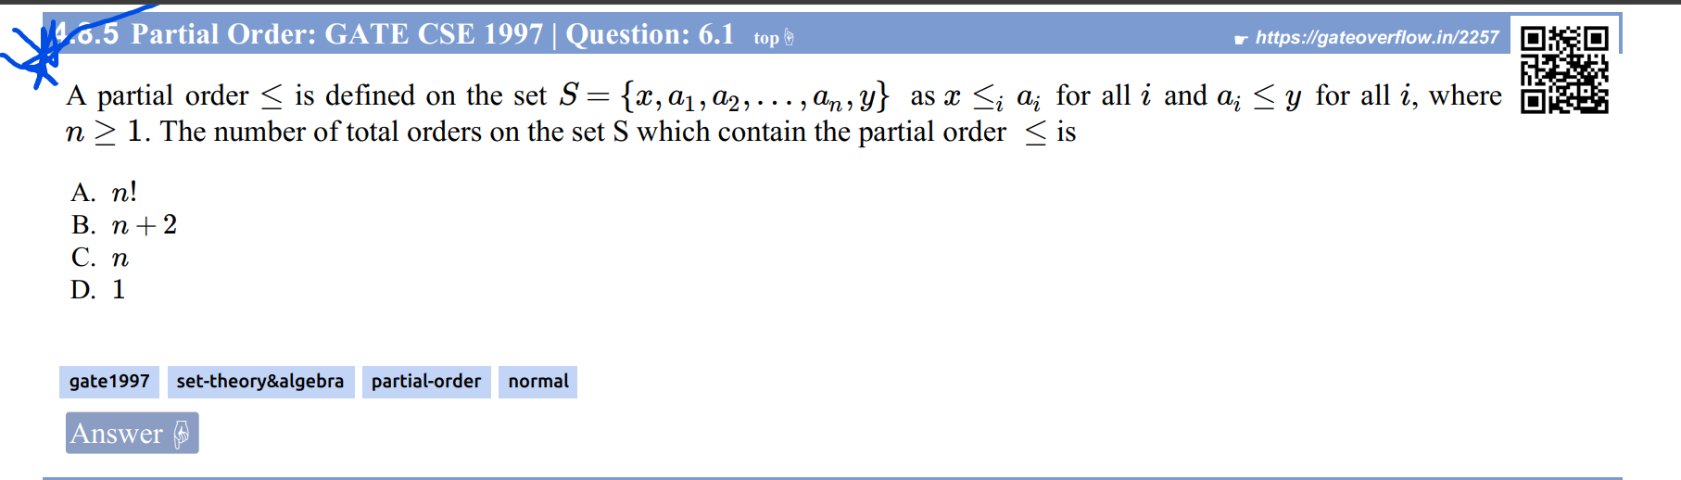

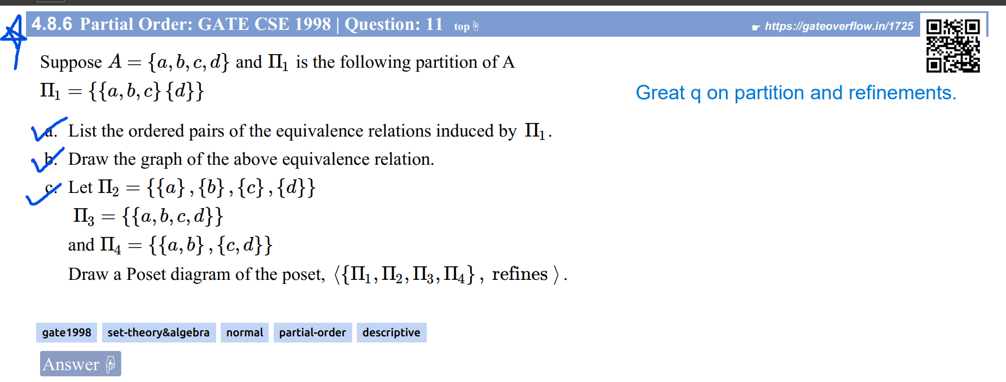

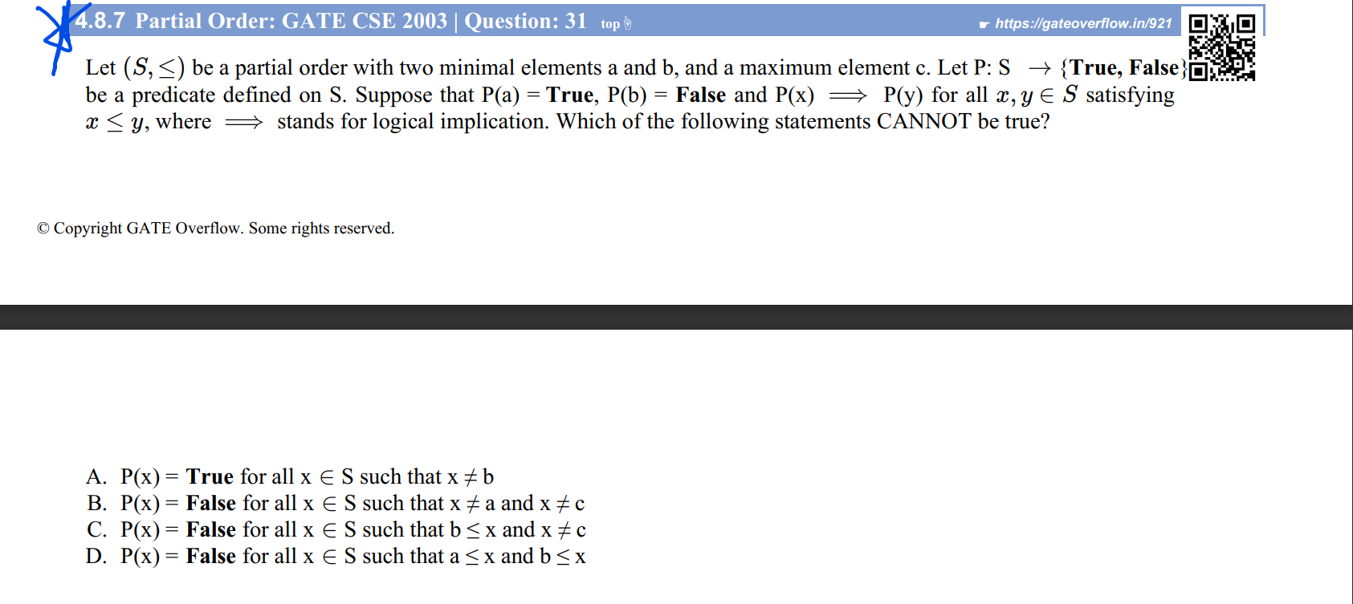

Ans: 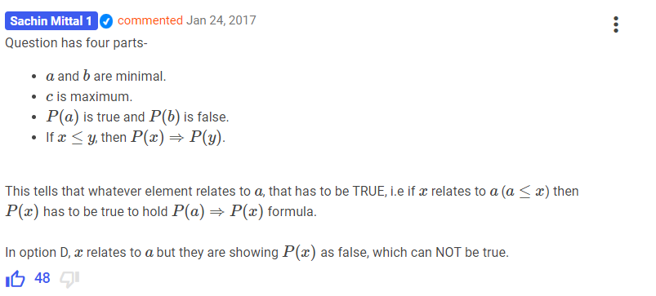

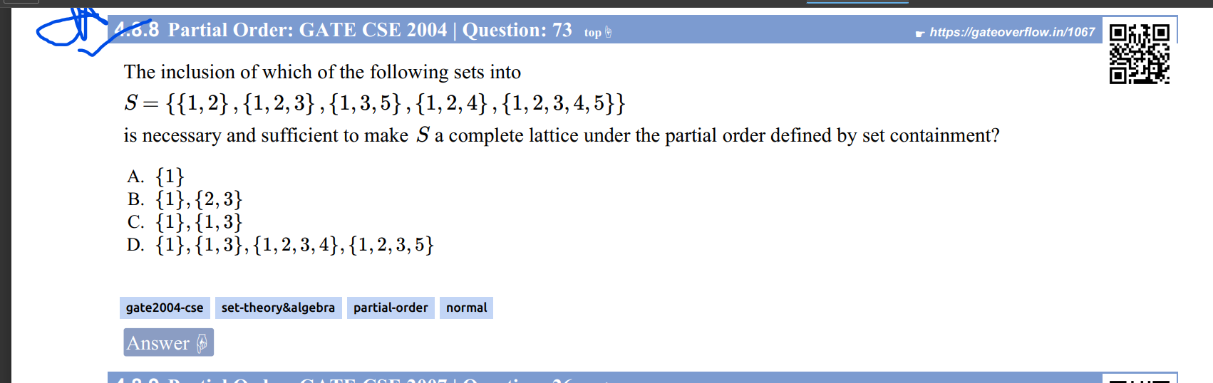

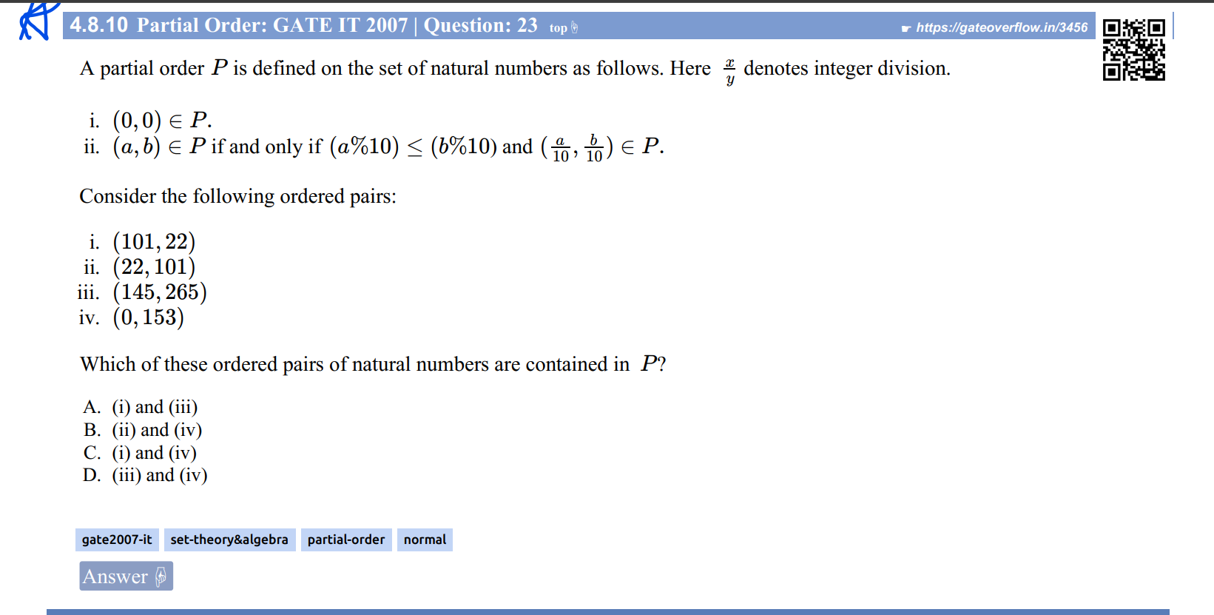

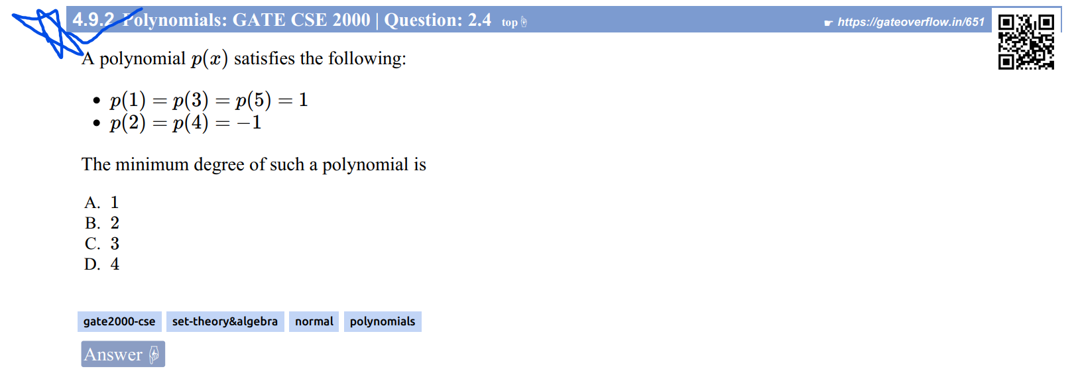

Ans : See the technique used here : [What is the minimum degree of a polynomial, given the initial conditions? - Mathematics Stack Exchange](https://math.stackexchange.com/questions/675110/what-is-the-minimum-degree-of-a-polynomial-given-the-initial-conditions/675137#675137)

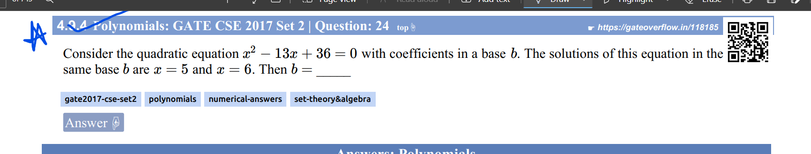

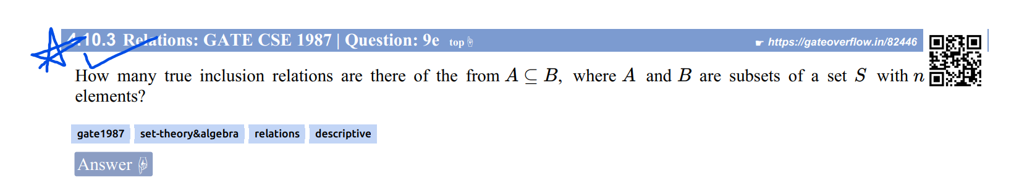

Ans: [TIFR CSE 2010 | Part A | Question: 18 - GATE Overflow for GATE CSE](https://gateoverflow.in/18496/tifr-cse-2010-part-a-question-18)

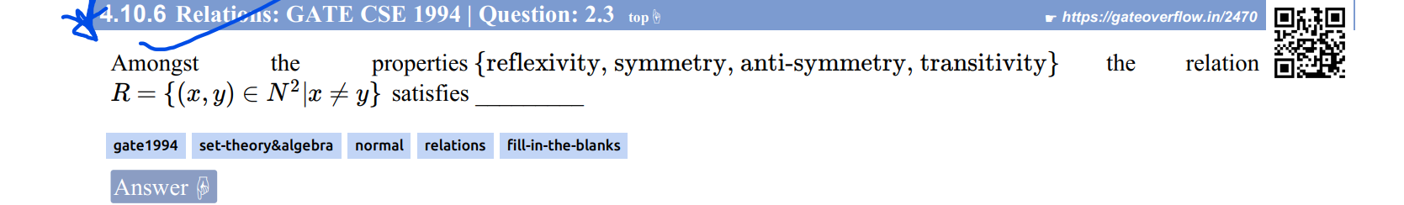

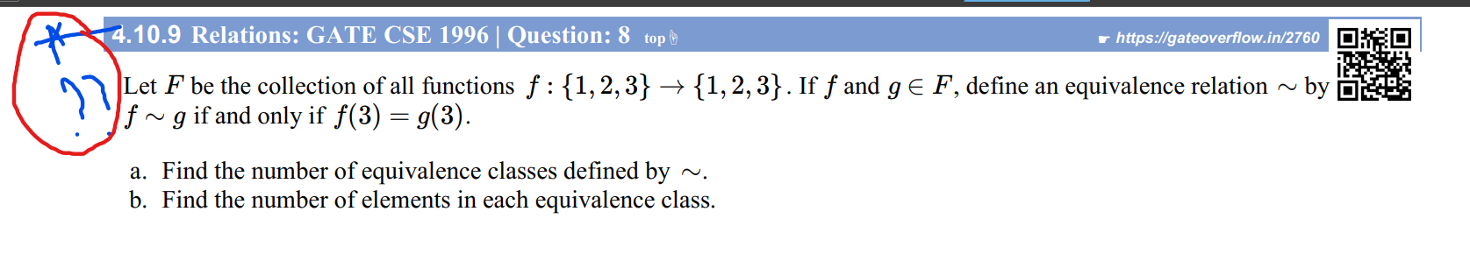

Great and very tough question. Read my comment first where I have mentioned step by step comments to read to understand.

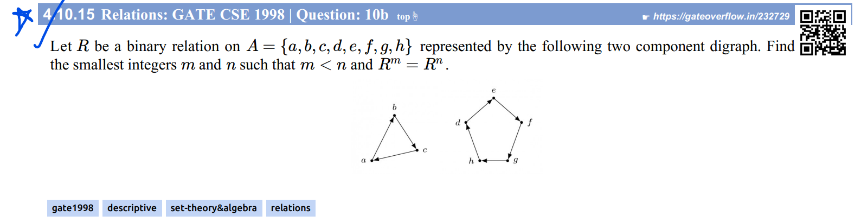

Ans: [GATE CSE 1998 | Question: 10b - GATE Overflow for GATE CSE](https://gateoverflow.in/232729/gate-cse-1998-question-10b#138066)

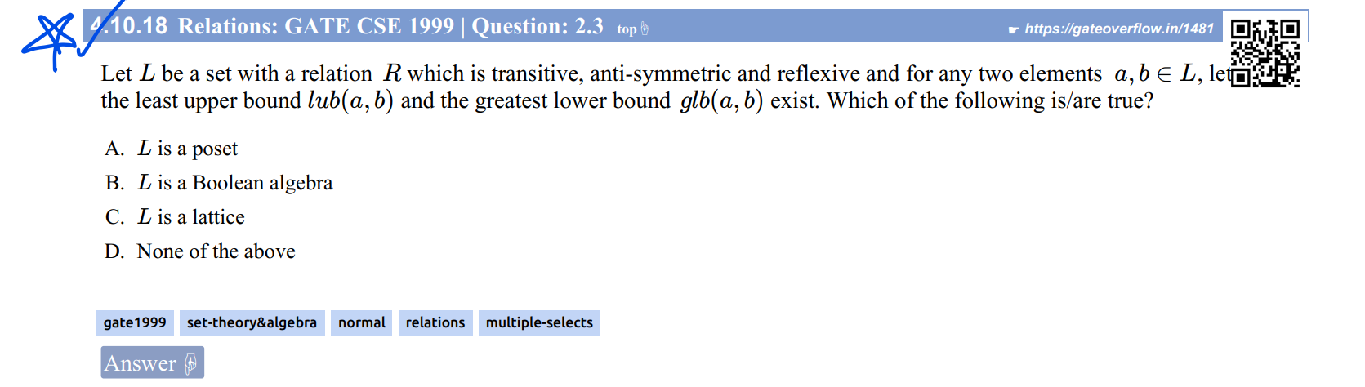

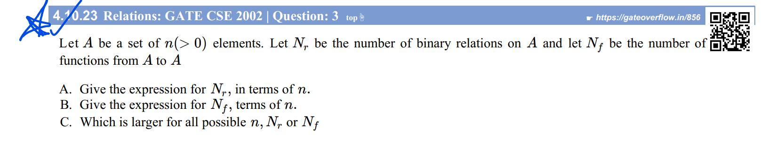

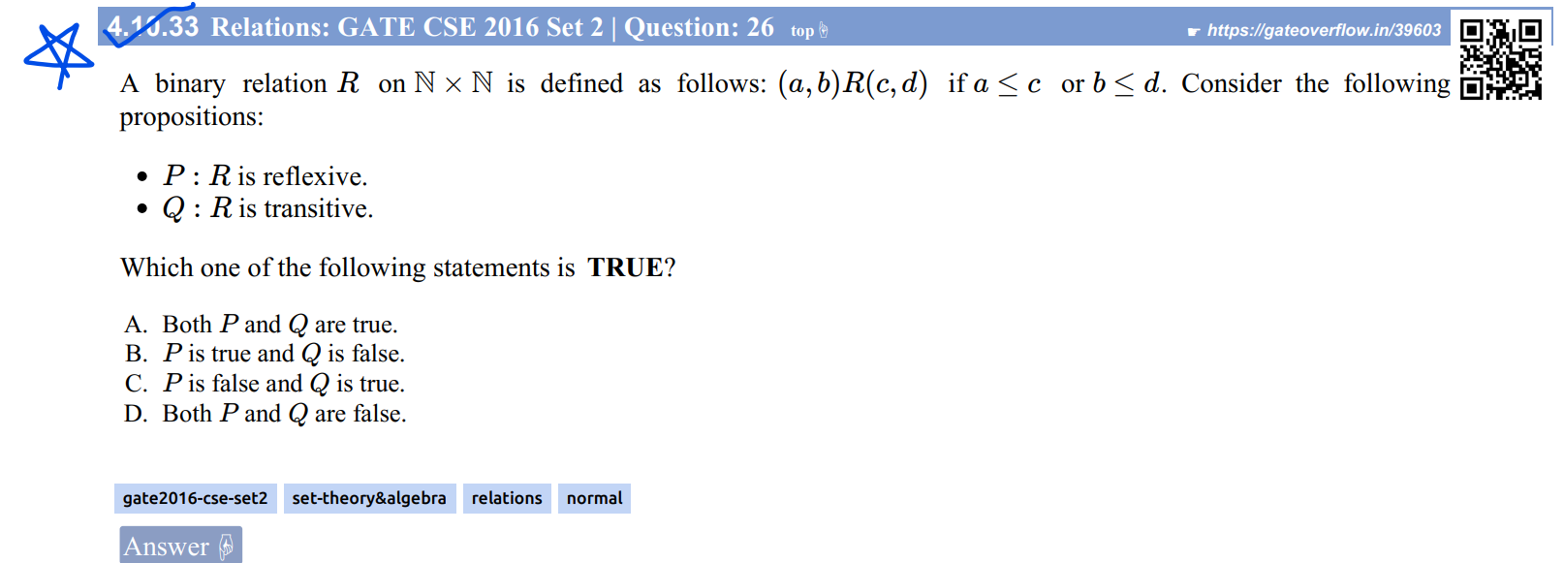

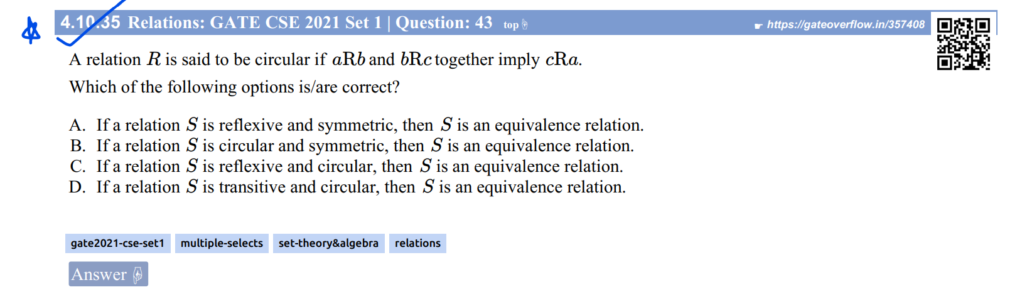

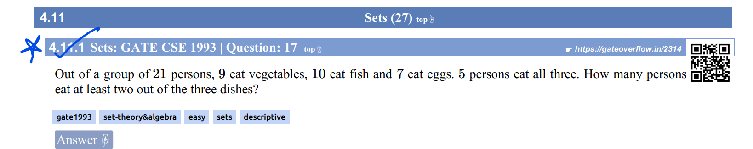

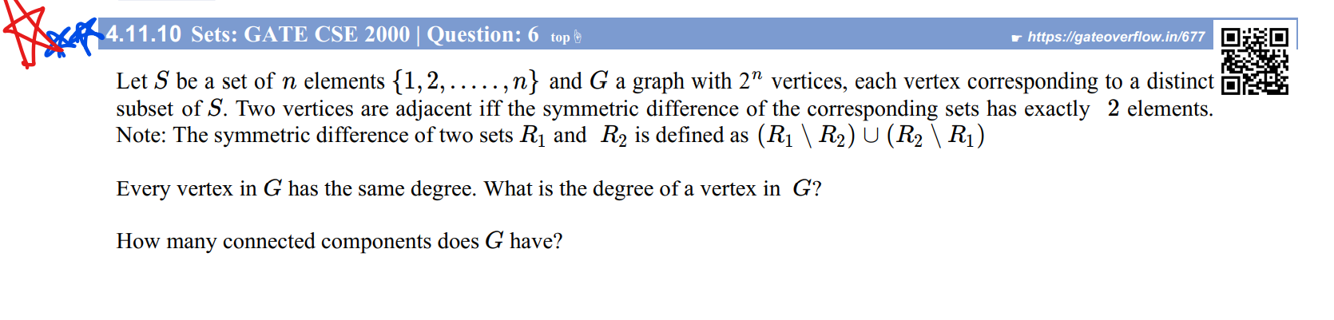

Didn’t understand the solution

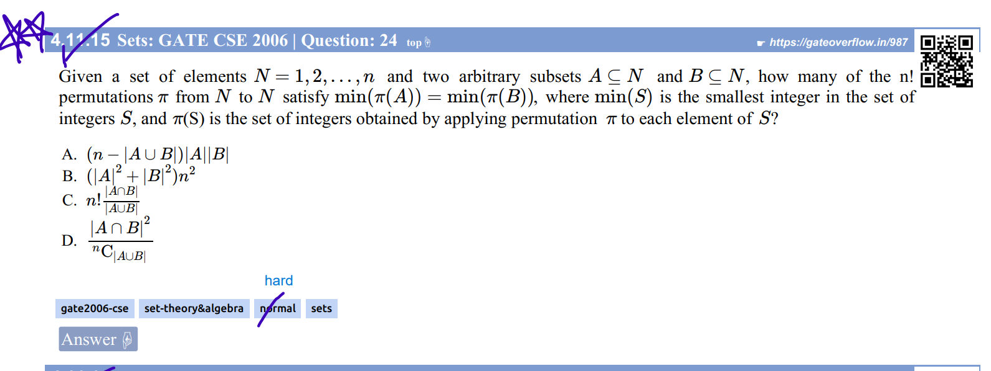Soln: <https://drive.google.com/open?id=1twqnDTFHKZNFYE3oPLUA8bPOUwhyOvH4>

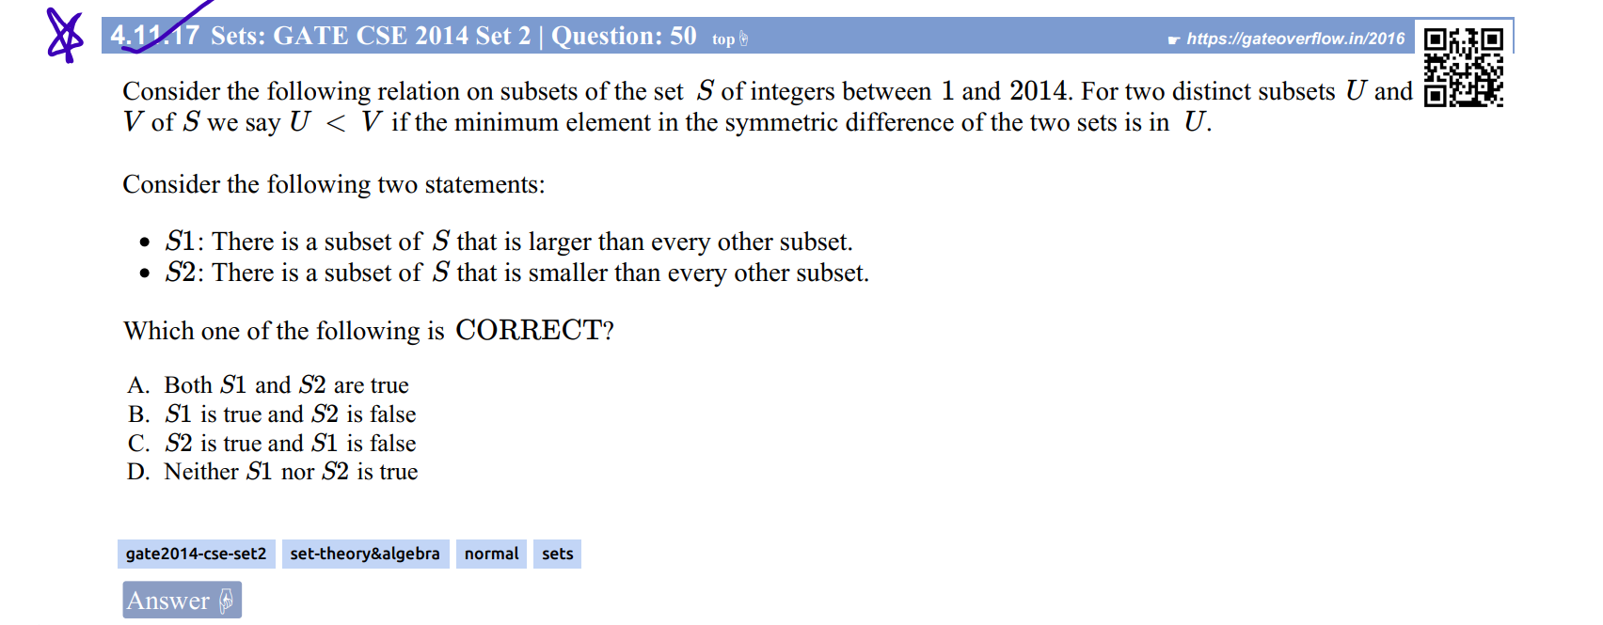

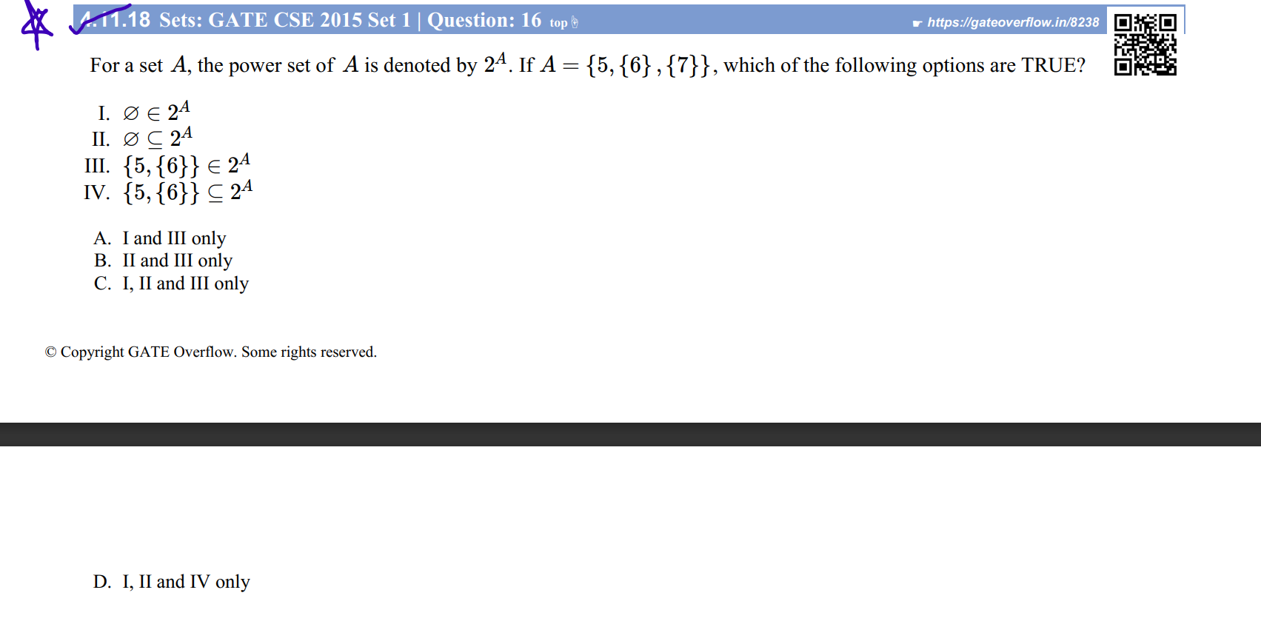

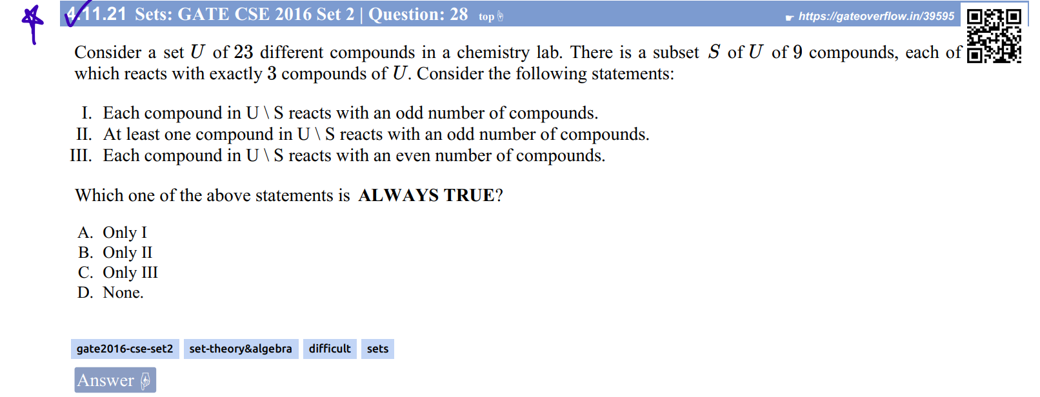

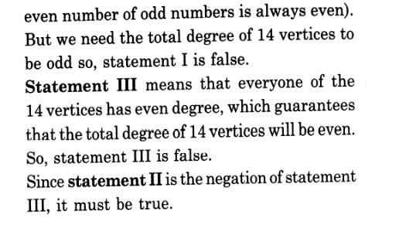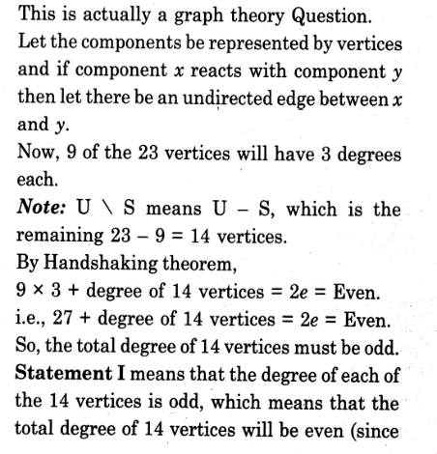Soln:

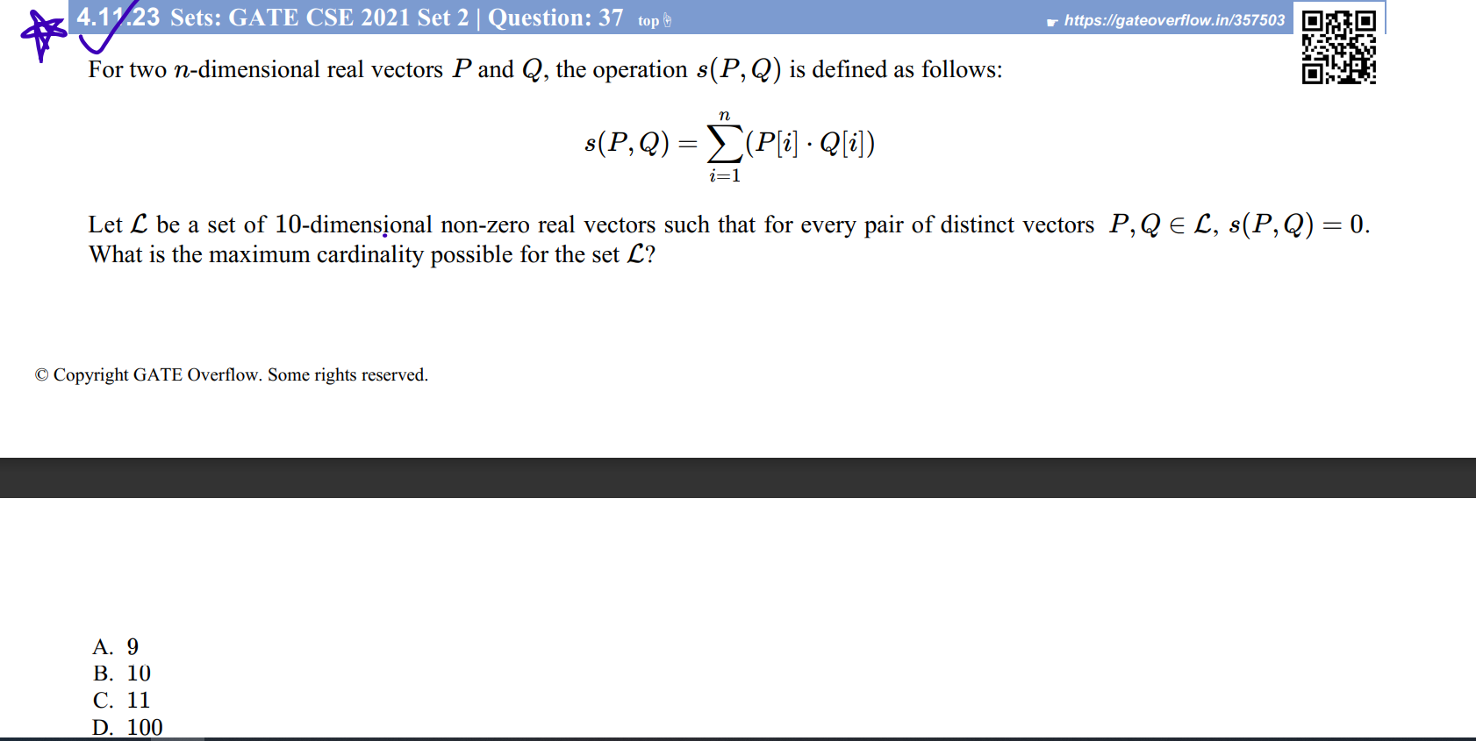

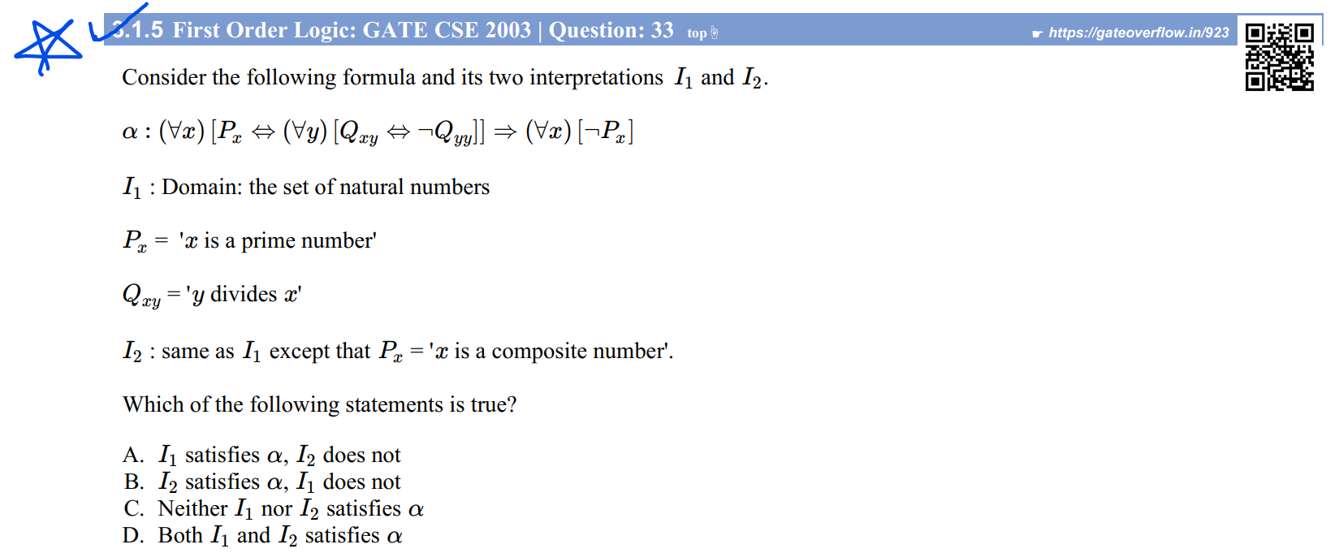

Ans: Read Sachin and Arjun both ans

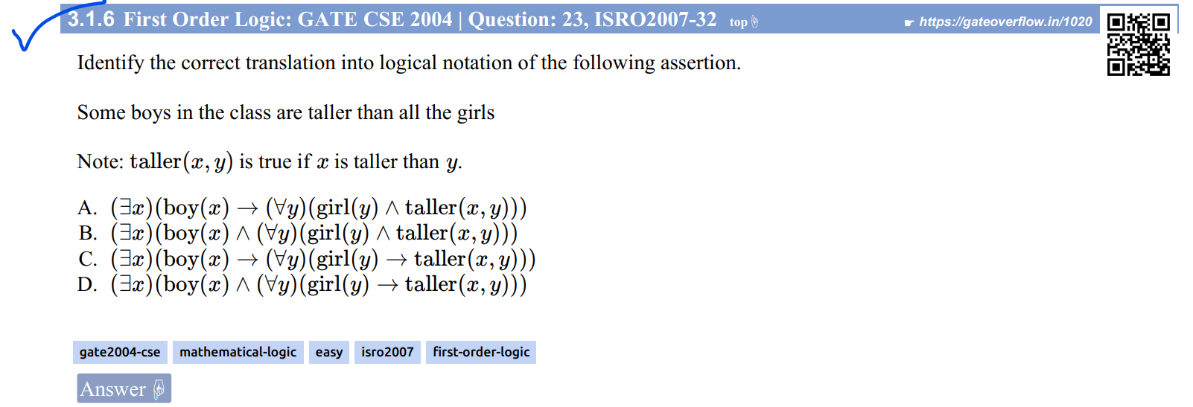

Must read the best ans :

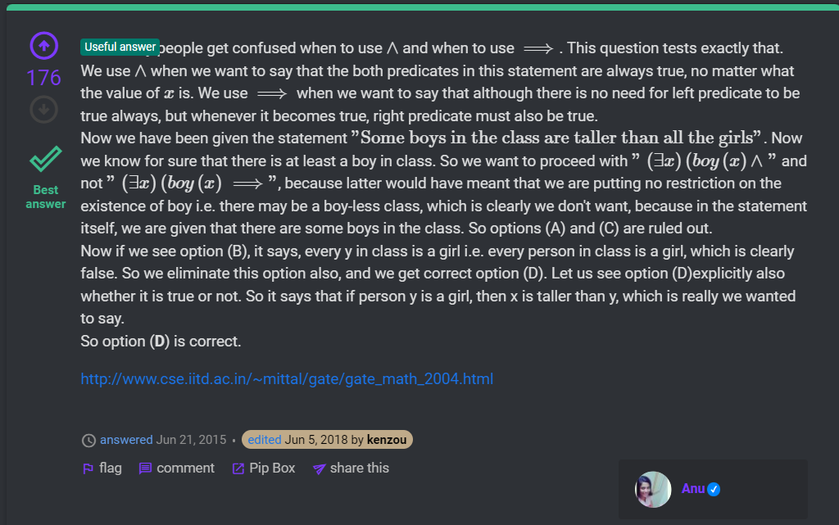

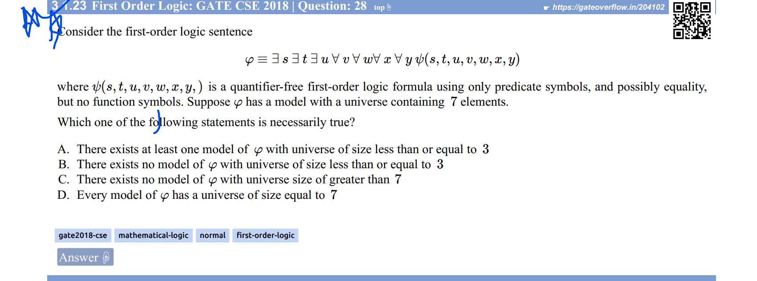

Ans: Read best as well as Kiran Sir’s ans

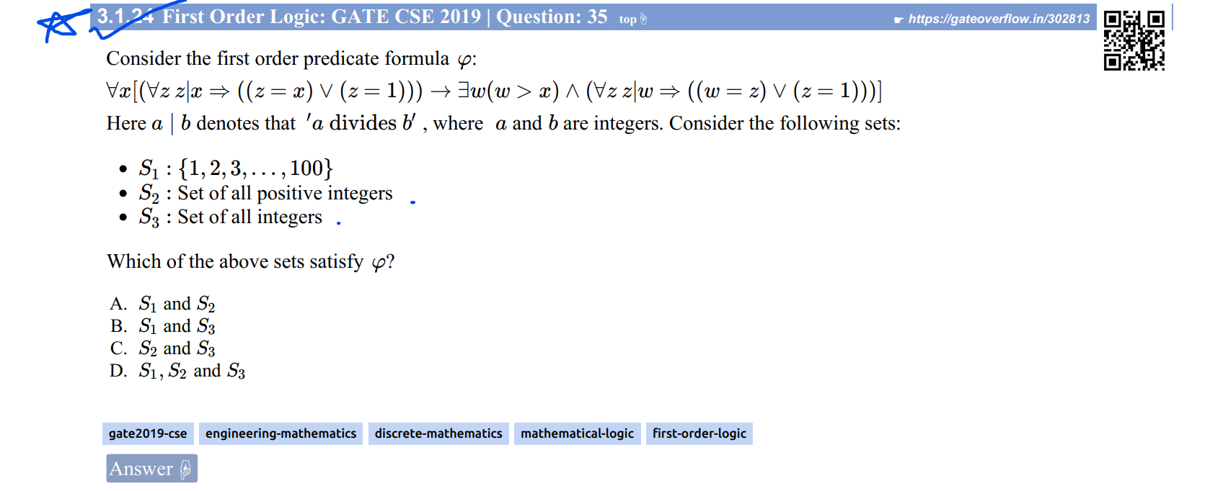

Read Deepak Poonia’s answer.

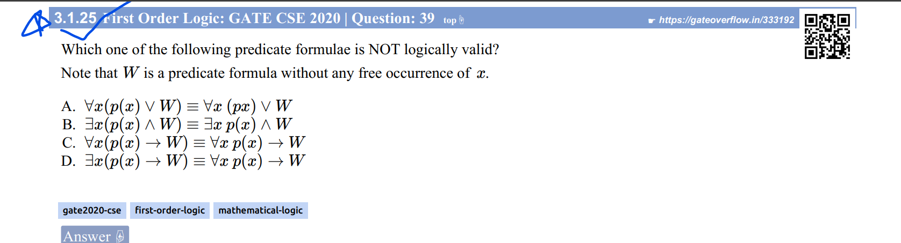

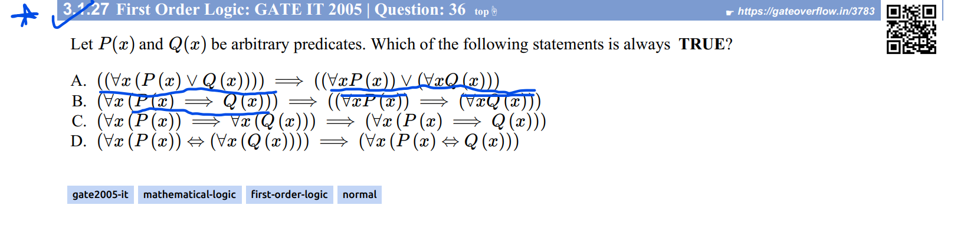

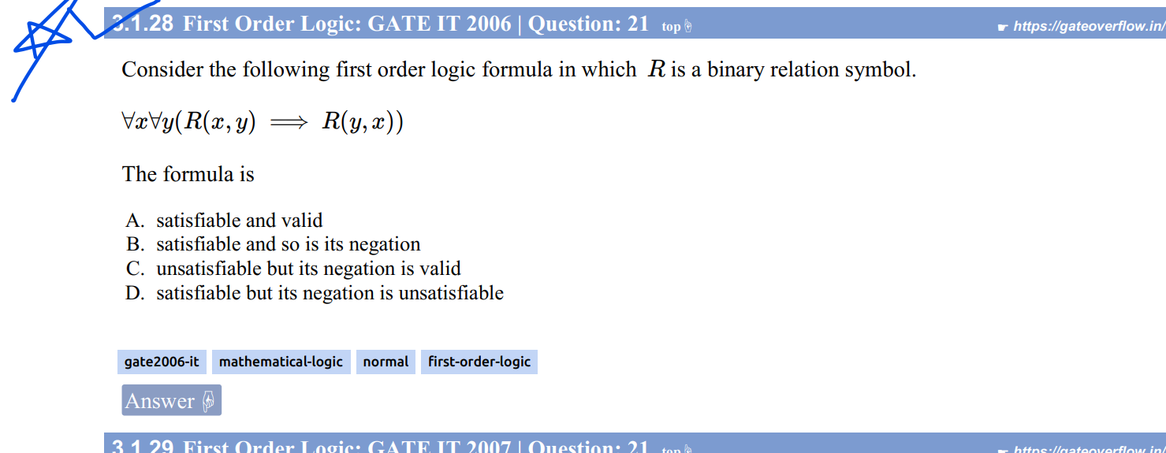

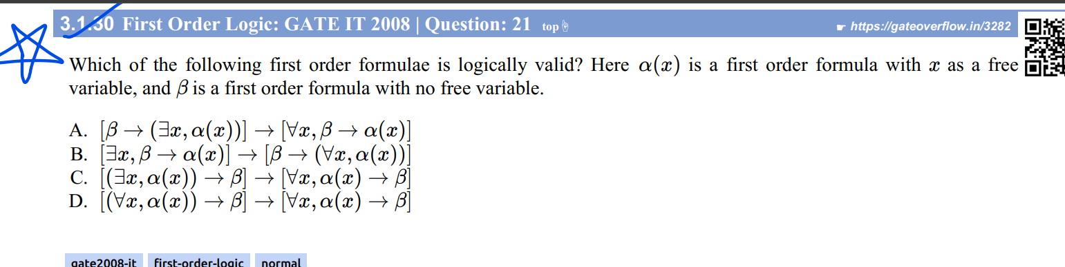

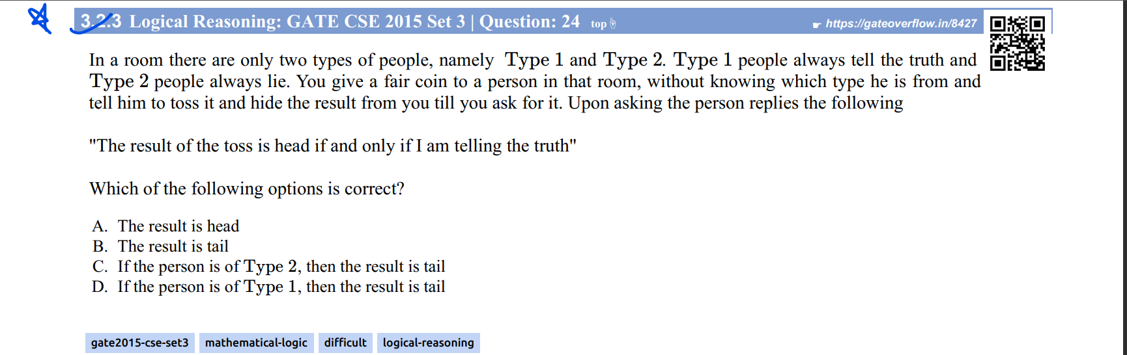

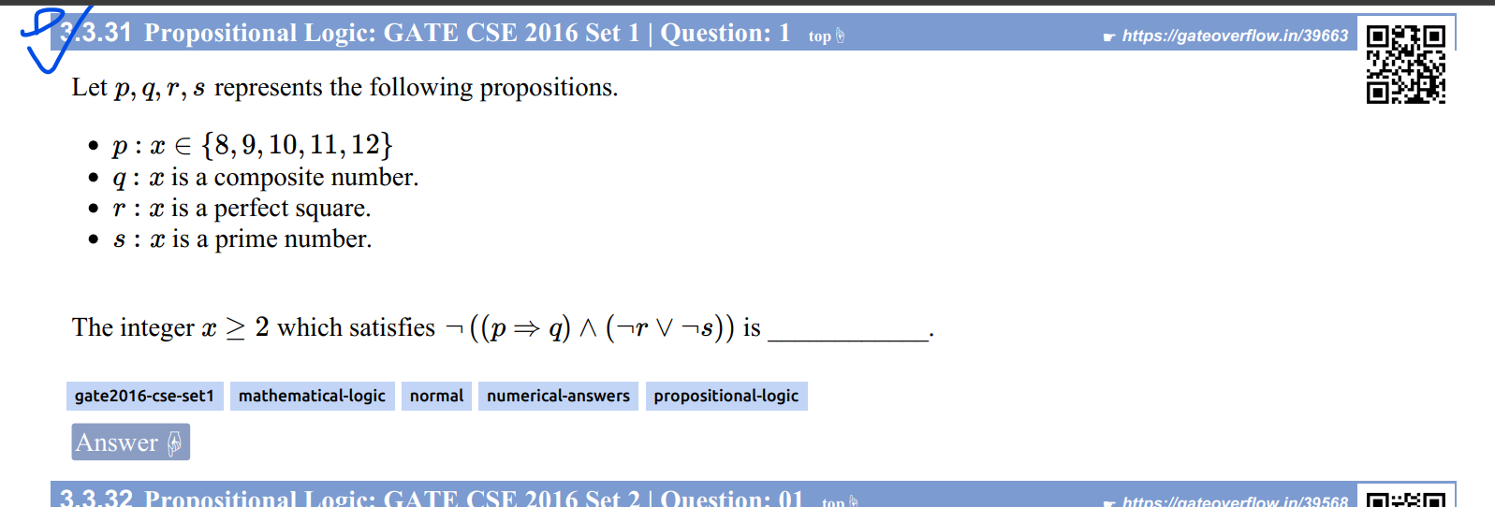

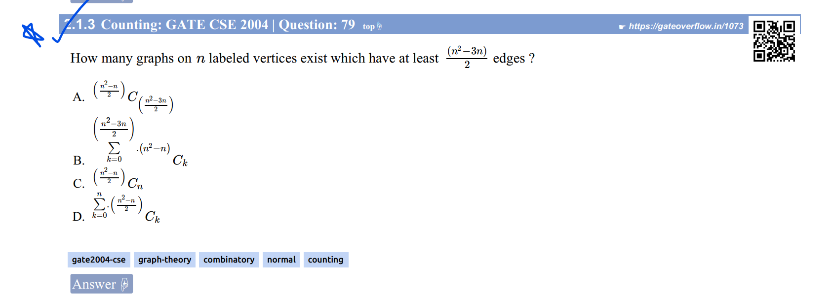

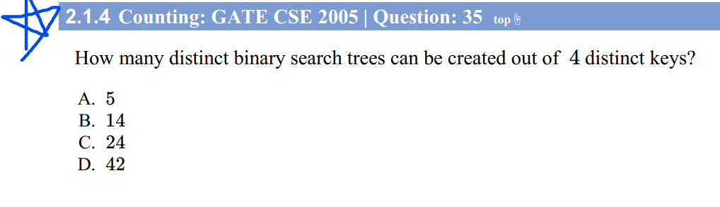

[Enumeration of Binary Trees - GeeksforGeeks](https://www.geeksforgeeks.org/enumeration-of-binary-trees/)

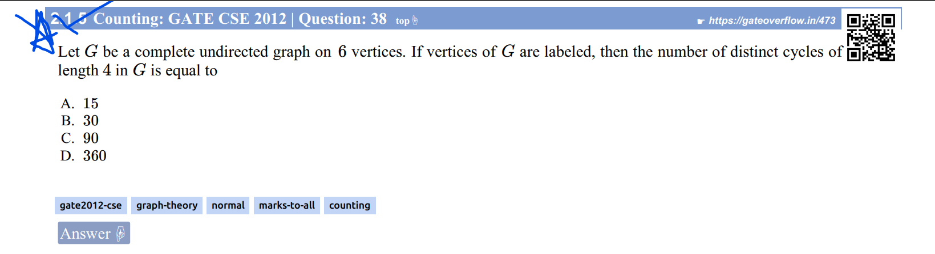

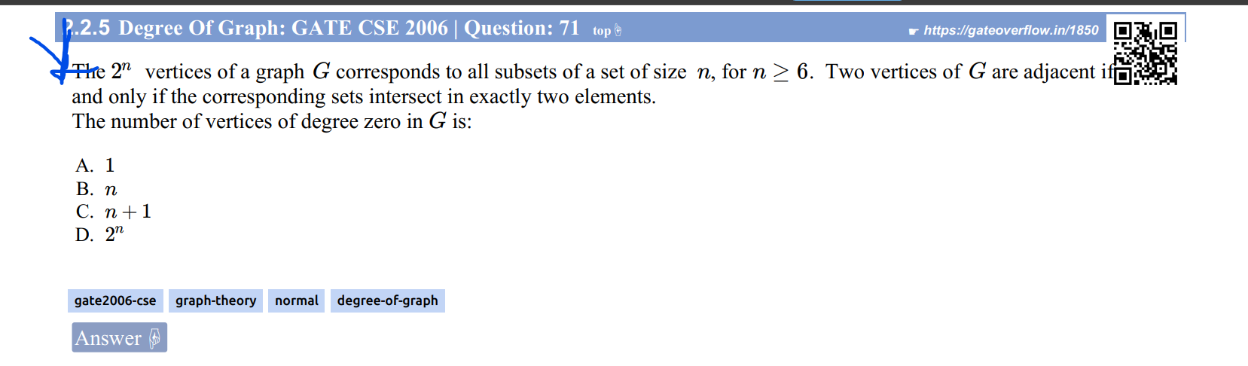

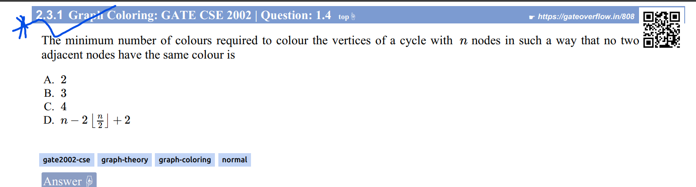

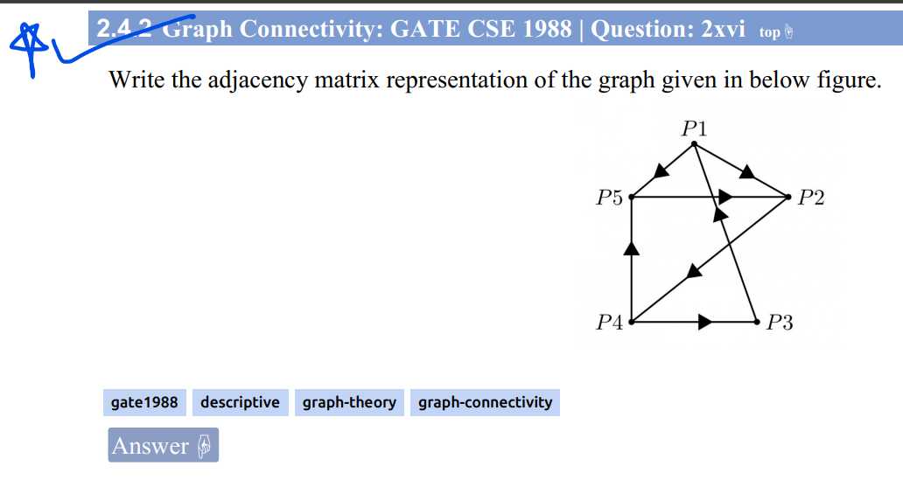

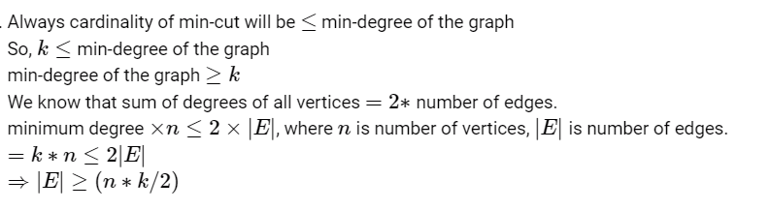

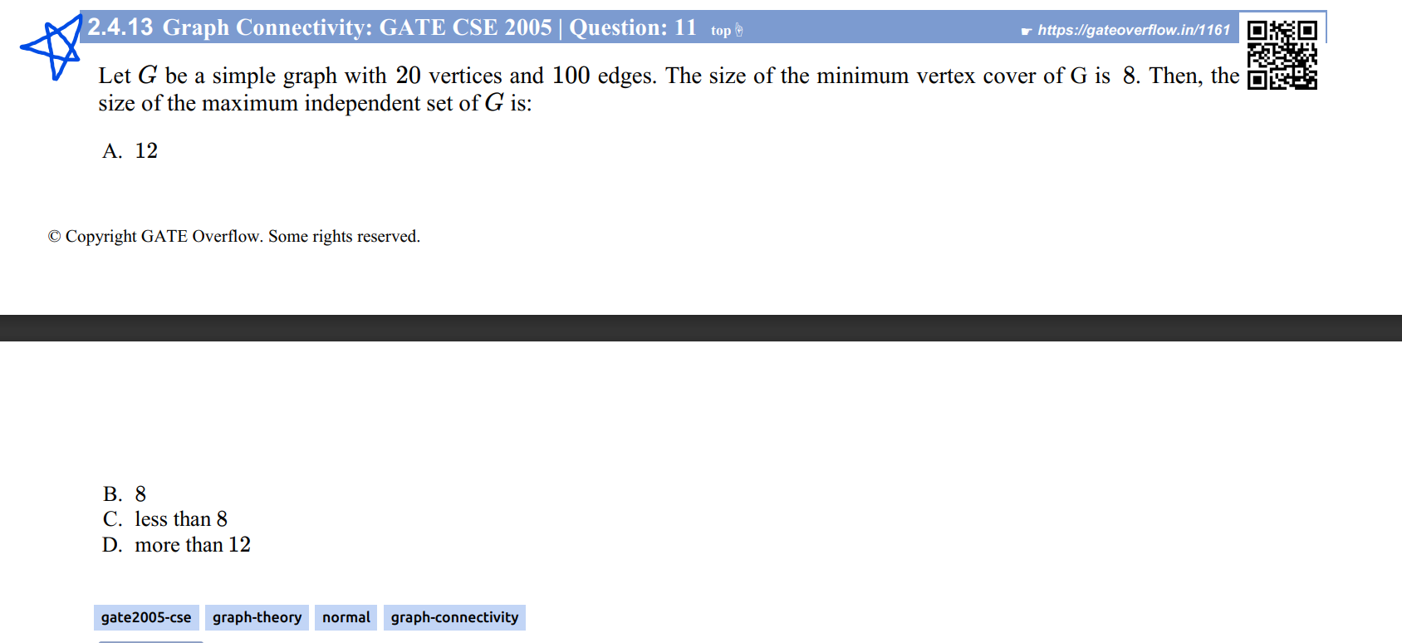

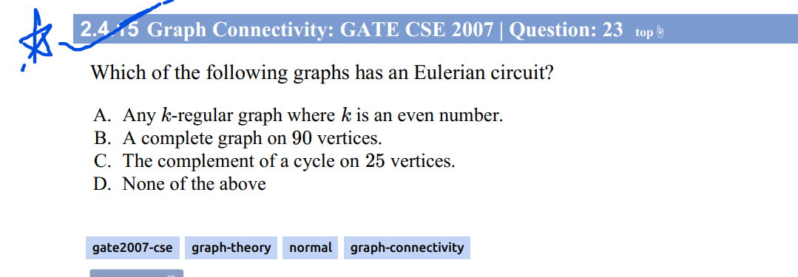

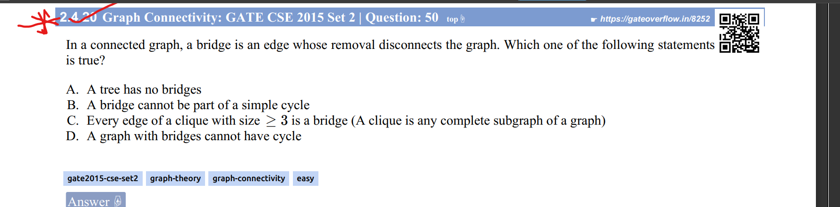

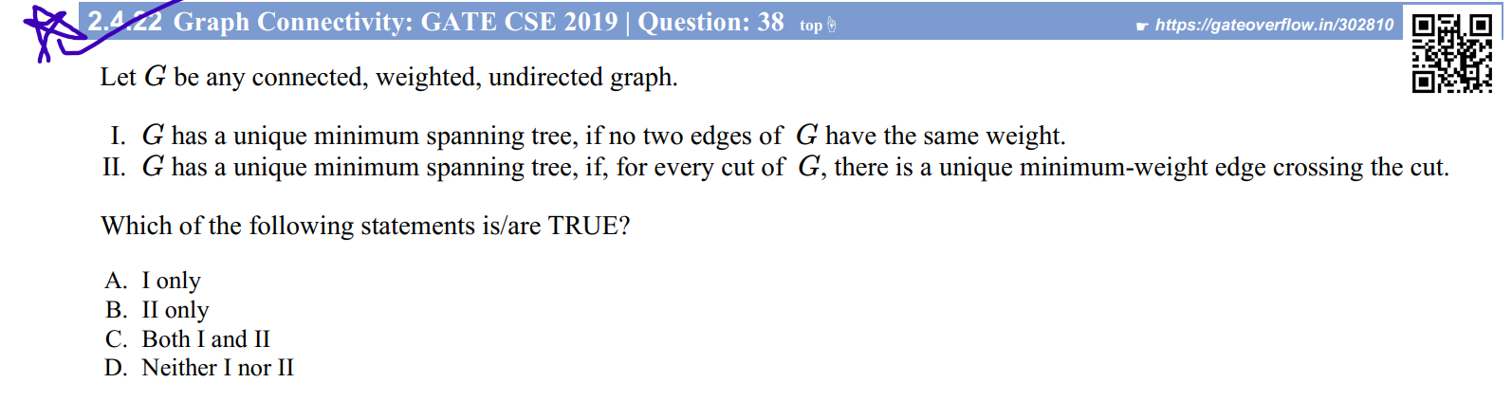

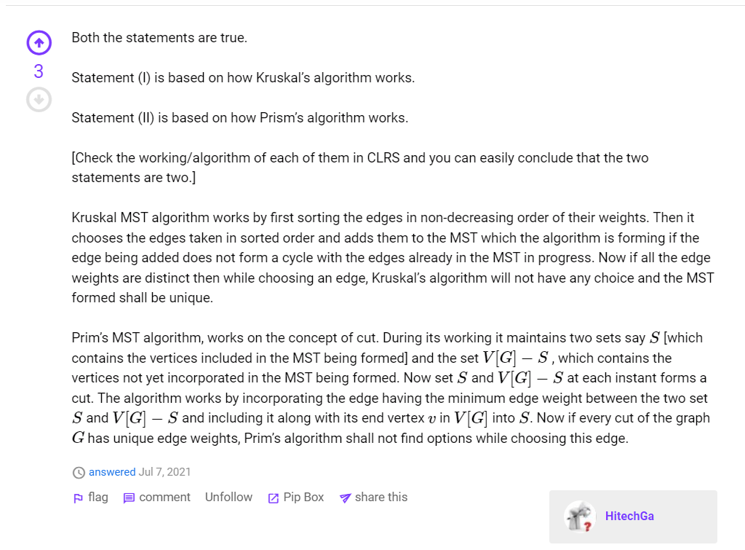

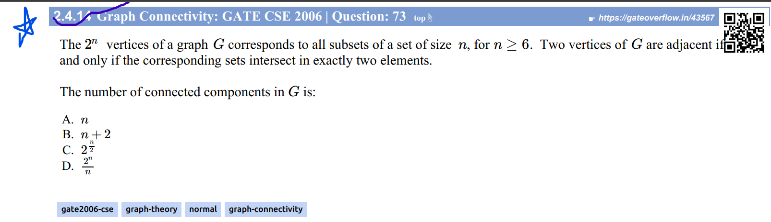

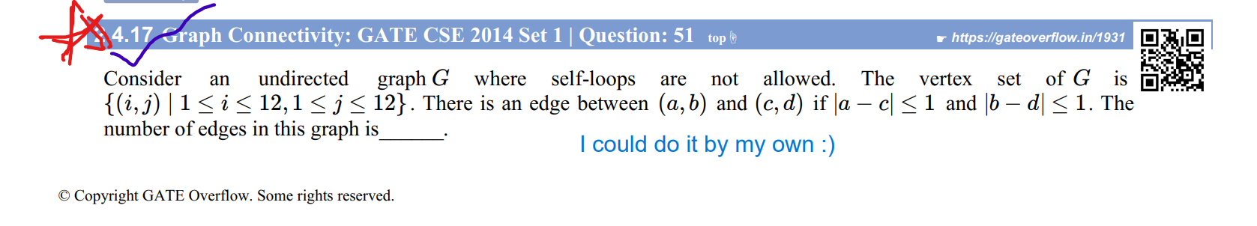

See my answer in Go Site, or see pg 329 in my Q practice copy

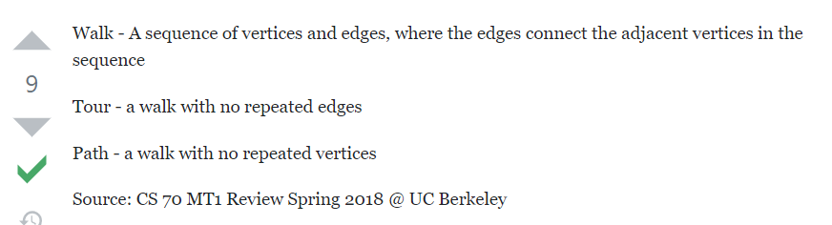

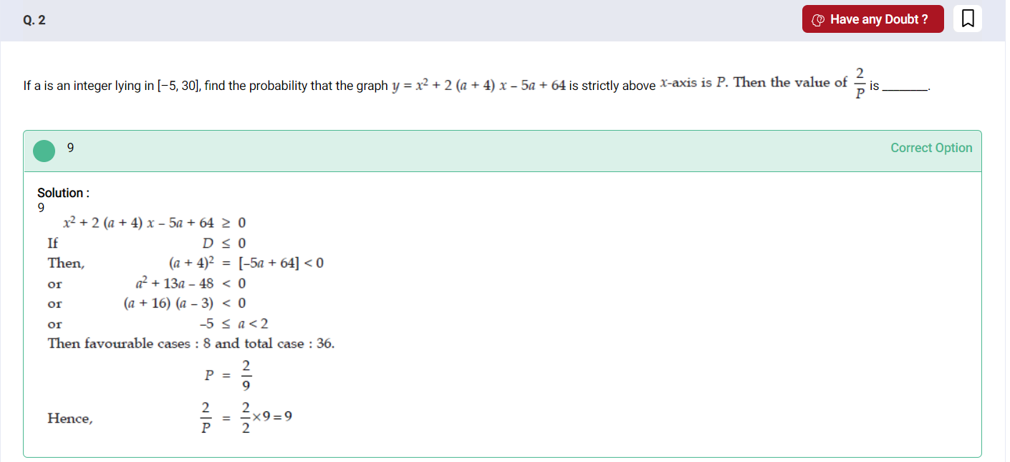

Ans:

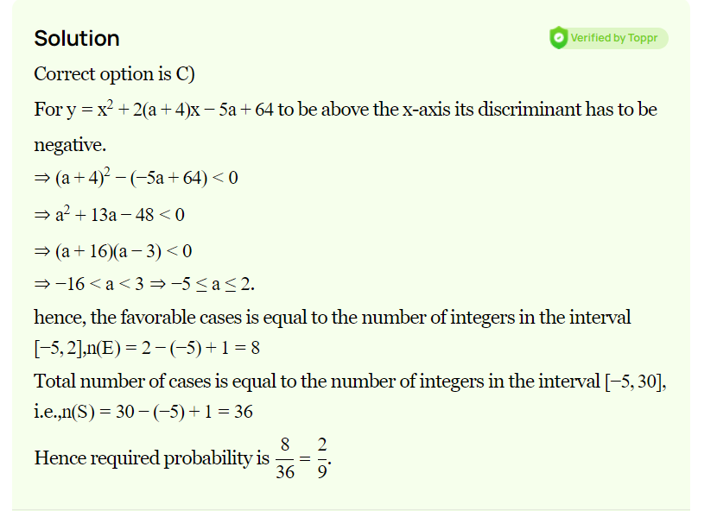

[Monday Puzzle: Two Heads In A Row – Mind Your Decisions](https://mindyourdecisions.com/blog/2015/02/16/monday-puzzle-two-heads-in-a-row/#:~:text=When%20the%20coin%20is%20fair,the%20number%20of%20consecutive%20tosses.)